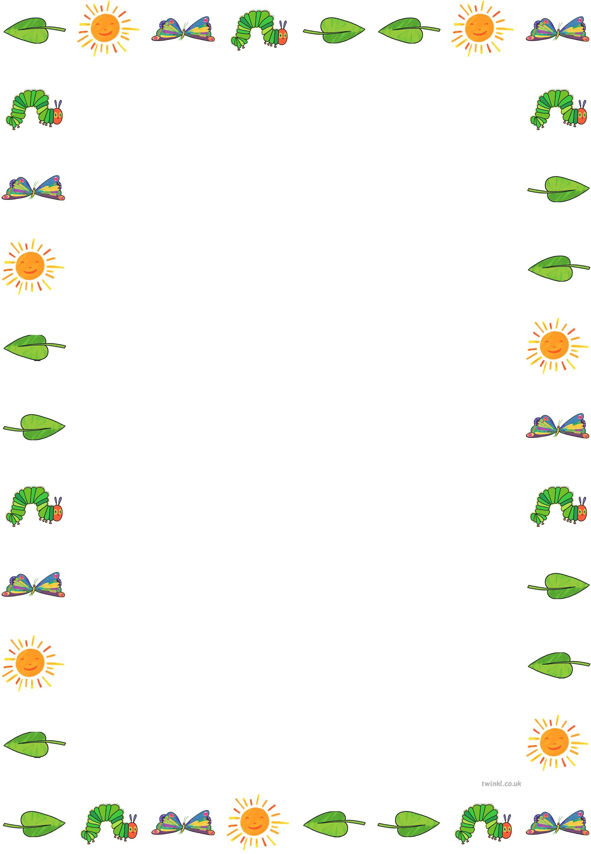

Class 1 weekly update

22nd – 26th April

**Our learning theme this week is:**

Caterpillars and Butterflies

**Book of the week:**

‘The Very Hungry Caterpillar’ by Eric Carle

**We are very excited to have the arrival of some caterpillars in class this week which we will be closely observing over the coming weeks and waiting for them to turn into butterflies!**

Nursery

* We will be practicing following 2-part instructions
* We will be sequencing the story of The Very Hungry Caterpillar
* In our Phonics time, we will be playing a rhyming words game.

Can you think of a word that rhymes with:

dog rat mouse

Reception

* In Mrs Deane’s/Miss Atkins phonics group, we will be learning the sounds ‘air’, ‘ure’ and ‘er’. In Mrs Sim’s group, we will be practising reading and writing words with adjacent consonants, e.g ‘spell’
* In maths, we will be looking at 3D shapes: learning the names and properties.

Can you find anything in your house that is the same shape as these?

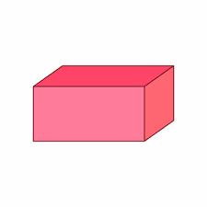  

Cuboid cube cylinder

***A few polite reminders:***

* ***Please can you ensure that all of your child’s items (including jumpers, water bottles and coats) are clearly named.***
* ***Please remember that children should only be bringing water in their bottles to school. We’ve had a few squash/juice spillages recently which cause sticky stains on the carpet.***
* ***Please ensure that long hair is tied up daily.***

***Thank you for your understanding ☺***