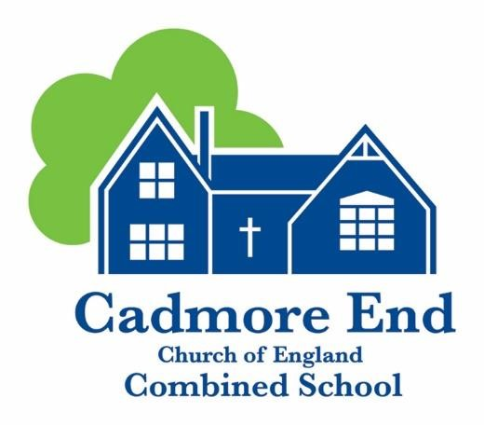

English Policy

Written: June 2021
Update January 2023

English Policy
January 2023
‘From small beginnings come great things.’
The parable of The Mustard Seed.
Matthew 13:31-32

This English policy reflects our Cadmore End core values and vision: To be the Nursery and Primary school of choice; providing a happy, safe and high quality education. We will apply our Christian and British values, complemented by our small-school benefits; balancing each child’s educational, pastoral and emotional needs, delivering an exceptional, personalised journey, enabling them to flourish in our family, our community and in the future.

The policy has been formulated through consultation with staff members, parents, pupils and the school governors. Latest research and government advice has been adhered to. The governing board have been informed of all draft procedures and a draft policy has been presented to the English Governor. The final draft of this policy will be approved at a full Governing Body meeting.

Rationale:
English is a rich, expressive and exciting language. At Cadmore End Primary School, we recognise the crucial importance of studying the English language. Improved performance in reading, writing and spoken language will enable our pupils to express their thoughts and ideas more fluently and accurately in a variety of different ways. This will also help them to deal more successfully with other curriculum subjects, while enriching their lives beyond school. The teaching and learning of language skills are therefore given a high priority in our school as well as exposing our children to a rich variety of reading materials.

Aims:
It is our aim at Cadmore End Primary School to:
- Develop effective speaking and listening and teach children to:
  - use the vocabulary and grammar of Standard English
  - formulate ideas and express them clearly
  - adapt their speech to a wide range of circumstances and demands
  - listen, understand and respond appropriately to others
- Teach children to be effective readers who:
  - are able to use their phonic knowledge to blend words when reading
  - read accurately, fluently and with understanding and enjoyment focussing on both word reading and comprehension
  - understand and respond to the text/s they read
  - read, analyse and evaluate a wide range of texts, including literature from English heritage and from other cultures and traditions
- Teach children to be effective writers who use:
  - their phonic knowledge to segment words when writing
  - compositional skills – verbalising sentences, developing ideas and communicating meaning to a reader in a variety of styles and for different purposes
  - effective transcription skills – accurate punctuation, correct spelling and legible handwriting – including encouraging a correct pencil grip and a continuous cursive script
  - accurate grammar and a wide-ranging vocabulary, organising and structuring sentences correctly and presenting whole texts coherently
- Be aware of the diversity of the language children bring to school and appreciate that the richness of dialects and other languages can make an important contribution to pupils’ knowledge and understanding.
- Give children opportunities to develop their understanding and use of Standard English and recognise that there are different forms of language dependent upon the audience and/or context.

Planning:
Lesson planning is modelled on the work of the Statutory Framework for the Early Years Foundation Stage (2021), The National Curriculum (2014) and the work of leading English Educational trainer’s such as Pie Corbett and Julia Strong’s, ‘Talk for Writing’ Framework. Wherever possible, writing is linked to the termly class topics and the wider school curriculum. There is a balance between fiction, non-fiction and poetry with an emphasis on whole texts rather than extracts and worksheets. An example of our whole school curriculum map and requirements can be found below – Appendix A and B.

Resources:
Each class has a reading area and access to the school library. Reading scheme books have been amalgamated from a variety of sources and providers. They are matched accurately to support progression. Guided Reading texts are kept separately within each classroom. Resources are replaced or added to in accordance with the English Action Plan.

Phonics:
Our Phonic scheme is Twinkl. This has been approved by the DFE in December 2021. Phonics is taught daily in classes one and two. If a child does not complete phase 6 by the time they enter Class 3 (Year 3), an intervention would be introduced e.g. Direct Phonics. Our reading scheme also supports the progression of phonics.

Reading:
Evidence suggests that children who read for enjoyment every day not only perform better in reading tests than those who don’t, but also develop a broader vocabulary, increased general knowledge and a better understanding of other cultures.
In fact, reading for pleasure is more likely to determine whether a child does well at school than their social or economic background! (Pearson 2021). At Cadmore we have over 200 books from a variety of reading schemes. Each scheme supports a different aspects of a child’s reading journey. In line with 2022 DFE expectations, early reading is linked to our Twinkl Phonics, allowing pupils to practice reading the sounds they have learnt in class.

Handwriting:
We place value on children taking pride and care over their work and handwriting is a key part of this. In the Early Years Foundation Stage, there is a big emphasis upon developing the physical skills needed to write. Our children are exposed to a variety of fine and gross motor skills daily and taught to print letters initially. As the children move into Key Stage One, they are taught to join their letters using a pre-cursive script, form letters and numbers consistent in size and shape and use the correct pencil grip. (Appendix C) Handwriting is taught weekly through discrete sessions and the children are encouraged to use the continuous cursive script in their writing and when rehearsing their spellings. As the children move into Key Stage Two, the children develop their script further and are rewarded for consistent handwriting by receiving a ‘Pen Licence.’

Library:
Reading should take place both for enjoyment and to assist in the retrieval of information. Children are able to change library books at various points during the week. All staff and children are responsible for keeping the library tidy and replacing the books on shelves correctly. The library provides quality resources to engage children's’ interest and assist teachers in curriculum delivery. The resources are regularly audited by the English Coordinator. A template letter is available (see Appendix D) to send home to children who fail to return their books. Should a book be lost at home, parents/carers will be asked to replace the book with a new one or make a donation of £5.00 to the school library.

Homework
Children are expected to read for a short time daily at home, with parents recording this. Spellings based on the sound being currently learnt at school are sent home and tested weekly in Key Stage One and Two. Children in the EYFS are provided with Key Phonics Sounds and ‘Tricky Words’ to learn at home each half term. The reading and spelling of Common Exception Words (Year 1 and 2) and the reading and spelling of the recommended spellings (Year 3-4 and 5-6) are tested termly and shared with parents.

Inclusion and Equal Opportunities:
We endeavour to maintain an awareness of all aspects of Inclusion and provide equal opportunities for all our pupils. We acknowledge that all children have an entitlement to take part in English activities regardless of ability, race, gender, religion, culture and social background. We aim to take this into account, in our teaching attitudes, displays and in the published materials we use with our pupils.

The school aims to create a sensitive attitude to children’s educational needs by providing differentiated activities within all areas in line with our Special Educational Needs and Able, Gifted and Talented Policies. Lessons are planned and delivered in a range of ways to allow for all children’s learning styles. Where children are identified as having a Special Educational Need, an Individual Pupil Profile will be written in consultation with the parents and SENCO.

Children highlighted as needing support by class teacher and SENCO in Reading may also receive:
- Phonics small group support
- Additional reading time with an adult
- Fine motor support and handwriting support groups
This provision is evaluated termly or more frequently and ties in with teachers’ Pupil Progress Meetings.
Cross Curricular links:
Where appropriate, opportunities are taken to deliver lessons that allow for cross curricular links. Our long term planning ensures lessons are fun and stimulating, building on children’s previous experiences and then extending their skills and knowledge. We also use ICT to enhance English lessons using relevant websites to support our English curriculum.

Health and Safety:
Please refer to our Child Protection, Online Safety, and Health and Safety policies.
All staff are required to make risk assessments both in advance of and throughout their lessons and involve the children as much as possible in taking responsibility for behaviour, areas, and equipment. These risk assessments need to be reviewed after any activities and appropriate amendments made.
Assessment and Reporting:
We acknowledge the importance of both summative and formative assessment and build in opportunities for these within our long and short term planning.

- Reading records are used weekly to indicate pupils’ progress. Guided reading group record sheets are kept to inform future planning.
- Reading comments are communicated to parents to assist in their children’s learning at home.
- Children’s skills and understanding are assessed throughout and class teachers use their records, observations, discussions with children and work in books to assess whether children are working towards, at their age related expectation or working beyond this at greater depth which will be recorded on Learning Ladders. The English Coordinator and Senior Leadership Team monitor these observations each half term as well as teachers Long Term Planning to check coverage, to offer ideas, support or advice where necessary.
- Parent consultation meetings and report cards are provided termly to discuss children’s progress, attainment and targets. Informal achievement is reported to parents on an ‘as and when’ basis.
- Alongside the report cards parents are also given the following information:
  - The parents of each Year 2 and Year 6 child can receive a copy of the levels achieved by their child in their SATs.
  - The parents of each Year 1 child receive a letter stating whether their child has or has not reached the pass mark for the phonics screening check.
  - The parents of each Reception child receive a copy of their child’s attainment against the Early Learning Goals.

Parents may request a consultation to discuss the above.
For assessment procedures please refer to School Assessment Cycle.
The Role of the Coordinator:
The English Coordinator is responsible, in conjunction with class teachers, for ensuring consistently high standards across the school. We aim to ensure that:
- Children experience a coherent and progressive curriculum throughout their time in school
- Teaching and learning are evaluated during and as a result of every lesson and planning is adapted accordingly
- INSET is attended to keep abreast of current initiatives and ‘best practice’
- Implications for teaching and learning are disseminated and implemented
- Resources (including working areas) are maintained and updated when necessary in line with subject budget
- Adults other than teachers are inducted, managed and monitored effectively
- Action plans are kept up to date and managed efficiently
- Policy is reviewed and updated via consultation with staff, parents, pupils and governors through formal and informal discussion.

Written on: June 2021
Updated: January 2022
Updated January 2023
Review date: January 2024
This policy will be reviewed in line with the Governors Curriculum Cycle.

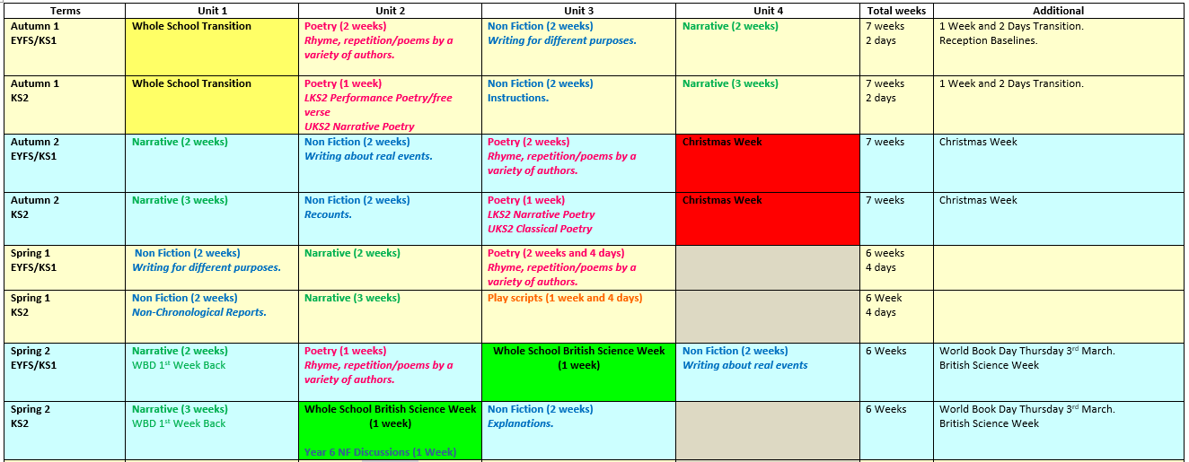
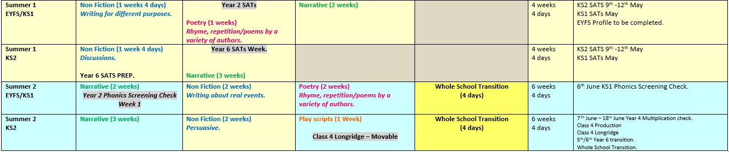
Appendix A - Example English Curriculum Overview – Whole School Cycle B
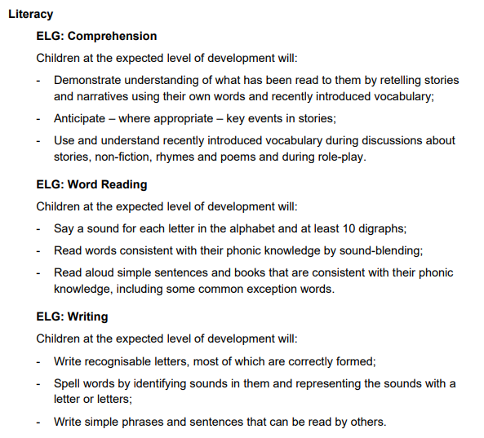
Appendix B – Requirements
EYFS English Requirements:
- Children actively engage with stories, non-fiction, rhymes, songs and poems.
- Provide extensive opportunities to embed words in a range of contexts. Through conversation, active storytelling and role play.
- Develop a lifelong love of reading – comprehension and word reading.
- Skilled word reading, transcription and composition.
New ELG’s from September 2021
KS1 English Requirements:
- Fiction: key stories, fairy stories and traditional tales. – Writing about personal experiences and those of others.
- Poetry: Rhyme, repetition and poems by a variety of authors.
- Non-Fiction: Writing about real events and writing for different purposes.
KS2 English Requirements:
- Fiction: Wide range of books from different authors and times – fairy stories, myths and legends, folk tales, traditional stories, modern fiction, fiction from our literary heritage and books from other cultures and traditions.
- Poetry: Classical, narrative, performance and play scripts.
- Non-Fiction: Instructions, Discussion, Explanation, Recounts, Non-Chronological Reports and Persuasive.

Appendix C – Continuous Cursive Handwriting Script and Pencil Grip Support Sheet.
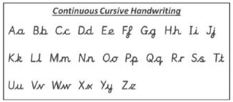

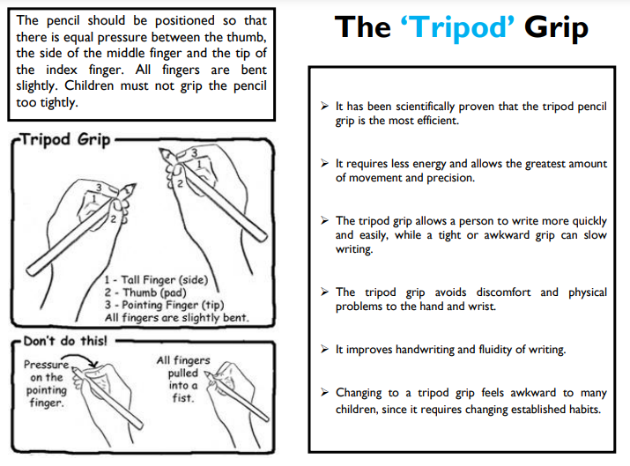

Appendix D - Lost Book Letter to Parents

Cadmore End, High Wycombe, Buckinghamshire HP14 3PE
Telephone: 01494 881460
Email: office@cadmoreendschool.org
Headteacher: Mrs. D Groom

Date
Dear Parent / Guardian,

Your child borrowed a library book called:_____________________________
On the following date: ____________________________________

It has not yet been returned.

Please could you supply a new book for our library or provide a donation of £5.00 to cover the cost of a replacement.

Thank you.

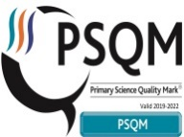
Web: www.cadmoreendschool.orgCharity Reg. No. 1066943

Love Faith Courage Honesty Respect Empathy

