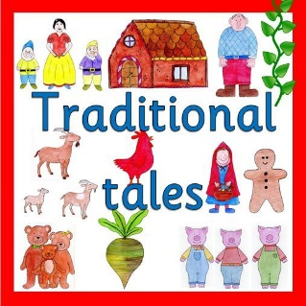
Class 1 weekly update

(30thJanuary- 3rd February 2023)

Our learning theme this week is: Storytelling week
Book of the week: A variety of Traditional Tales
School Values: This week we are focussing on respect

Nursery
- In talk time, nursery will be listening to & remembering rhyming sounds.
- They will also be listening carefully to some traditional tales and decide which one is their favourite and why. They will also be reading the story “Once upon a time in the wild wood” which links lots of the stories together!
Reception
- In phonics the children will be learning the sounds: oi and ear. The new sounds from last week and this week will be added to your child’s flashcard pack this week.
- In Maths, we will be continuing to explore the composition of 6, 7 and 8. We are also going to be continuing to subitise. To find out a bit more about subitising and how you can support your child in developing this skill, have a look at: www.bbc.co.uk/bitesize/topics/zkqf3j6/articles/zsjbcmn
- We will be focussing on the story of Hansel and Gretel and learning to retell the story in our own words. Later in the week we will be having a go at changing the story and rewriting the ending!
Makaton signs we have been learning
This half term we are focussing on colours. The children have been brilliant at learning these and can hopefully show you a few at home. If you would like to learn some too, have a look at the video below by scanning the QR code:

Spare clothes
A gentle reminder that every child must have a spare change of clothes at school in case they have an accident or get wet from water play. Sadly, we have not been getting clothes back from some parents who have borrowed school spare clothes. This has led to us having a very short supply at school. Please can you check at home and bring any spare clothes/socks as soon as possible.
If anybody has an old uniform, underwear or socks that their child has grown out of, we would be very grateful of any donations

