Early Years Snow Day Activities
Here are a few learning activity ideas for you. Have a go at as many as you like!
Can you write your name in the snow with your finger or a stick? How Deep is the snow? Can you see any icicles? You can use these for writing too, why not dip into paint! | Build a sculpture of some kind. It could be a snowman, snow child, snow animal or snow building. Find natural materials such as sticks or stones to add detail. Can you count them? | Set up a dig! Bury whatever you like in the snow in a designated area for the children to find. Count how many they have. These could be sorted in various ways afterwards too. Size, weight, plastic etc
Build a sledge for a small toy using objects in your house! Think carefully about what to use, which material will keep your toy safe and dry?  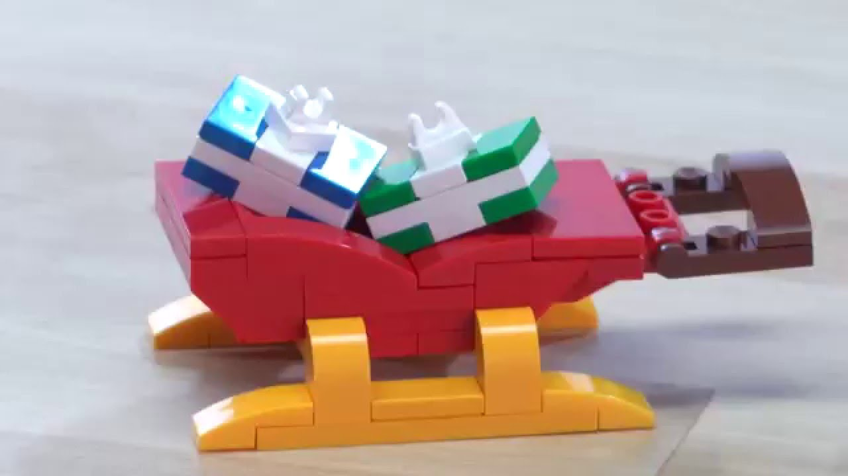 | Create a winter’s day café! What will you put on your menu to warm everyone up? We would love to see your menu and any photos.  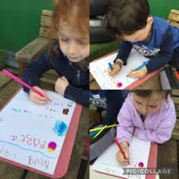 | Look for footprints in the snow. Can you see where people have been walking? Can you spot any other prints? Maybe from a dog, a bird or a cat! Can you make footprints too? Make a trail of footprints for someone to follow.
Birds find it really hard to find food when it snows. Can you make a bird feeder by threading hooped cereals onto some string or a pipe cleaner? Hang it in your garden or outside a window for the birds to enjoy on this snowy day. How many birds can you see? | Play target games with snowballs! Provide targets on a wall and on the ground, or even hoops hanging from a tree – with bonus points for hitting the tree trunk through the hoop! Can your child keep score of the points? | Put some small toys into small containers of water. Pop them outside and await to see what happens overnight! Have fun the next day helping them to break free. What can you use? 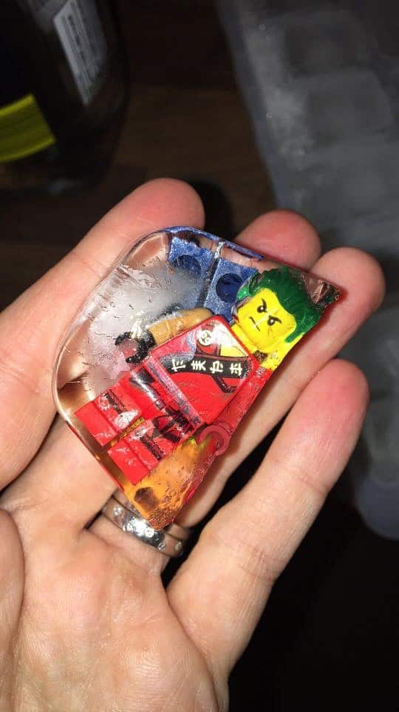

We would love to see pictures of what you get up to. Please could your grown-ups upload any pictures to Evidence me, or email us to the school office - office@cadmoreendschool.org
Have lots of fun in the snow!

