Class 1 English Long-Term Plan
Cycle B 2025-2026 Cycle A 2026-2027

Autumn Term | Autumn Term | Spring Term | Spring Term | Summer Term | Summer Term
Marvellous me | Let’s Celebrate | TBC | TBC | Life Cycles | Pirate trip around the world
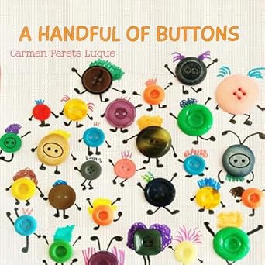  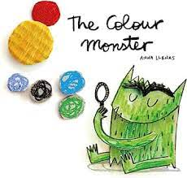  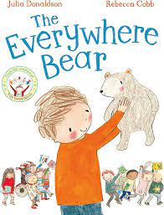 | 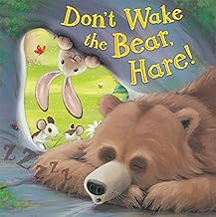  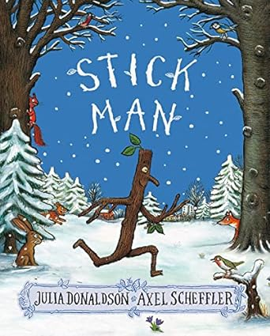  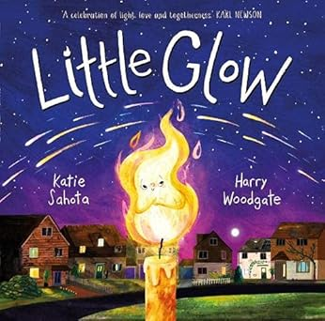 | TBC | TBC | 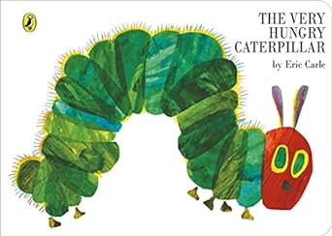  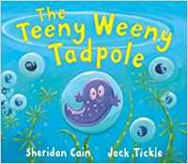  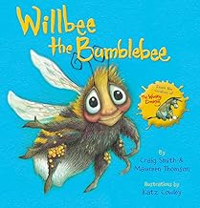 | 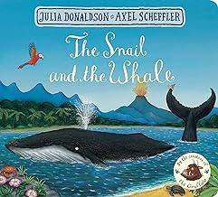  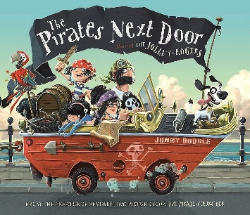  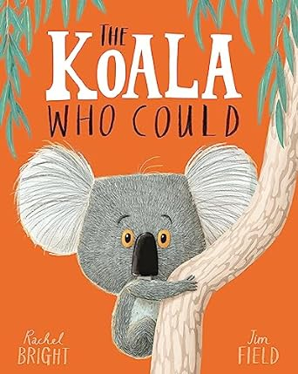
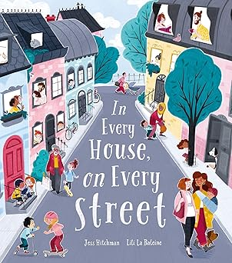  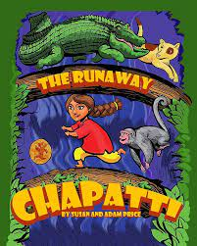  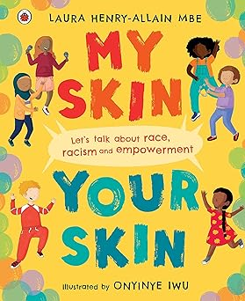  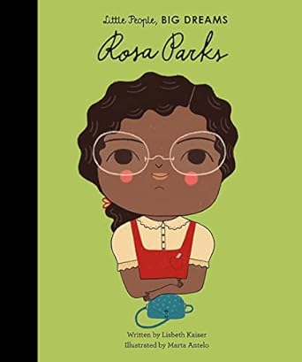 | 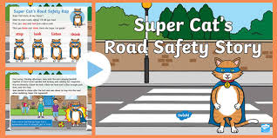  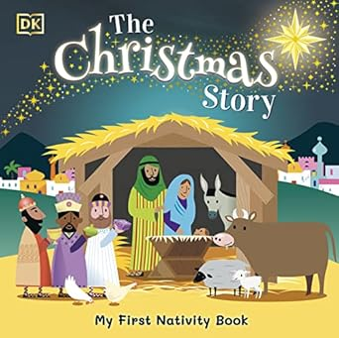 | 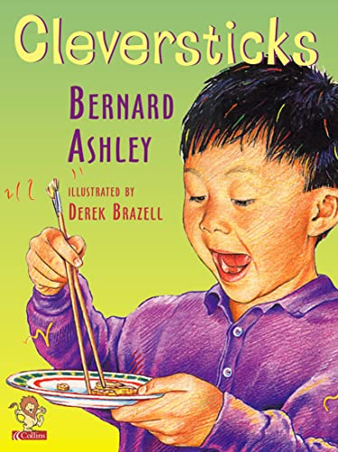 | 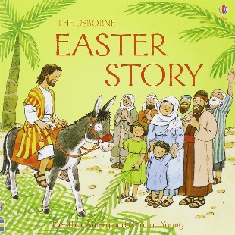 | 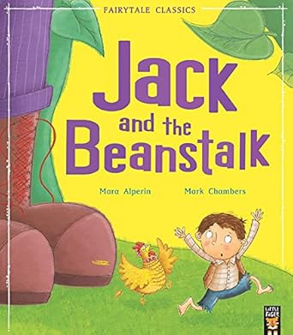

Purpose:  Entertain | Purpose:  Entertain | Purpose:  Entertain | Purpose:  Entertain/ Inform | Purpose:  Entertain/ Inform | Purpose:  Entertain/ Inform
Development Matters Statements

Age 3-4 Literacy (Listening to stories, writing)
Repeat words and phrases from familiar stories.
Ask questions about the book. Makes comments and shares their own ideas.
Develop play around favourite stories using props.
Notice some print, such as the first letter of their name, a bus or door number, or a familiar logo.
Enjoy drawing freely.
Add some marks to their drawings, which they give meaning to. For example: “That says mummy.”
Make marks on their picture to stand for their name.

Age 3-4 Communication and Language (Grammar, vocabulary)
Enjoy listening to longer stories and can remember much of what happens
Use a wider range of vocabulary
Know many rhymes, be able to talk about familiar books, and be able to tell a long story.
Develop their communication, but may continue to have problems with irregular tenses and plurals, such as ‘runned’ for ‘ran’, ‘swimmed’ for ‘swam’.

Age 3-4 Physical Development (Fine motor)
Use a comfortable grip with good control when holding pens and pencils.
Show a preference for a dominant hand

Reception Literacy (Listening to stories, writing)
Form lower-case and capital letters correctly.
Spell words by identifying the sounds and then writing the sound with letter/s.
Write short sentences with words with known letter-sound correspondences using a capital letter and full stop.
Re-read what they have written to check that it makes sense

Reception Communication and Language (Grammar, vocabulary)
Engage in story times.
Listen to and talk about stories to build familiarity and understanding.
Retell the story, once they have developed a deep familiarity with the text, some as exact repetition and some in their own words.
Use new vocabulary in different contexts.
Engage in non-fiction books.
Listen to and talk about selected non-fiction to develop a deep familiarity with new knowledge and vocabulary
Learn new vocabulary.
Use new vocabulary through the day

Reception Physical Development (Fine motor)
Develop their small motor skills so that they can use a range of tools competently, safely and confidently
Develop the foundations of a handwriting style which is fast, accurate and efficient.

Early Learning Goal Literacy (Listening to stories, writing)
Write recognisable letters, most of which are correctly formed.
Spell words by identifying sounds in them and representing the sounds with a letter or letters.
Write simple phrases and sentences that can be read by others
Demonstrate understanding of what has been read to them by retelling stories and narratives using their own words and recently introduced vocabulary.
Anticipate (where appropriate) key events in stories.
Use and understand recently introduced vocabulary during discussions about stories, non-fiction, rhymes and poems and during role play.

Early Learning Goal Communication and Language (Grammar, vocabulary)
Offer explanations for why things might happen, making use of recently introduced vocabulary from stories, non-fiction, rhymes and poems when appropriate.
Listen attentively and respond to what they hear with relevant questions, comments and actions when being read to and during whole class discussions and small group interactions. • Make comments about what they have heard and ask questions to clarify their understanding

Early Learning Goal Physical Development (Fine motor)
Hold a pencil effectively in preparation for fluent writing – using the tripod grip in almost all cases.

Cycle A TBC

