Class 1 weekly update

(18th- 22nd September 2023)

Our learning theme this week is: Myself and My family
Book of the week: Monkey Puzzle Poem of the week: Families
Collective worship: Our Bible story this week is all about ‘God the maker’, Psalm104. We will be thinking about things in the world we are grateful for. We will also be learning about our first school value: Courage.
Date for your diary!
Friday 29th September- We will be performing a short song during Celebration Assembly for Harvest as we will not be going to the church in the afternoon. You are welcome to attend. We can film this on Evidence Me for those unable to be there.
Nursery
- As part of our phonics we will be looking at selections of objects which start with the same initial sound
- In maths we will be practising our counting up to 5, then 10.
- We are going to have fun starting a new activity: Story Dough.

Reception
- Last week the children wowed us with their enthusiasm when we started our phonics adventure, learning the sounds s,a,t,p. This week we will continue to practise those sounds and introduce some new ones too: i,n,m,d. Each lesson involves blending sounds together to read simple words such as ‘tap, pan’ etc. Can you think of an object beginning with these sounds?
- In our Maths carpet time this week, we will learning about matching objects and talking about why they are the same/different.
Makaton signs of the week

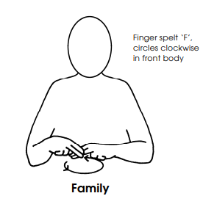
- We will be talking about our families and painting a self-portrait.
Reminders
Start time
Just to remind you that our doors will open at 8:35am and the register is taken at 8:45am. Any arrival after this time will unfortunately be marked as late.
Family photos
Thank you to everyone who has bought in photos already. If you are yet to do so, please send one in this week (hard copy/email/Evidence Me) for your child to use as a talking point to the class.

