

PSHE Policy

Member of staff responsible: Mrs D Groom Headteacher
Governor responsible Mrs B Zeun
Created July 2020
Reviewed/updated: July 2026
Next Review date: July 2027

_________________________________________________________________________________
Personal, Social, Health and Economic Education (PSHE)
2026-2027
‘From small beginnings come great things’ The Parable of the Mustard Seed
Matthew 13: 31-32
We will apply our Christian and British values, complemented by our small-school benefits; balancing each child's educational, pastoral and emotional needs to deliver an exceptional, personalised journey, enabling them to flourish in our school family and in the future.
1. The aim of this policy is to:
- Provide information to staff, parents and carers, governors, pupils and other agencies regarding the organisation, content and approach to teaching PSHE Education
- Help parents and carers to understand PSHE Education and support them to work with their child to secure the very best outcomes for all pupils
- Demonstrate how the school meets legal requirements with regards to teaching Relationships Education, Sex Education and Health Education.
2. Introduction
Personal, Social, Health and Economic Education (PSHE) is a distinct curriculum subject and has both statutory and non-statutory elements as defined by the DfE. High quality PSHE education supports pupils’ personal, social, health and economic development, helps to give them the knowledge, skills, strategies and attributes to make informed choices and decisions about the different opportunities and challenges life presents. Pupils will learn about relationships, health and wellbeing, keeping safe, managing their offline and online lives, living in the wider world and financial education at an age-appropriate level. Providing a high quality PSHE curriculum gives pupils opportunities to explore issues that are real and relevant to them in their daily lives in a safe and managed environment.

3. The Legalities
At Cadmore End school we teach the statutory parts of PSHE – Relationships Education (please see our Relationships Education Policy) and Health Education through our PSHE curriculum. We also teach non-statutory sex education as part of PSHE provision (please see our Sex Education Policy.)
The Relationships Education, Relationships and Sex Education and Health Education (England) Regulations 2019, made under sections 34 and 35 of the Children and Social Work Act 2017, make Relationships Education compulsory for all pupils receiving primary education and Relationships and Sex Education (RSE) compulsory for all pupils receiving secondary education. They also make Health Education compulsory in all schools except independent schools.
The school has regard to the Department for Education’s statutory guidance, Relationships Education, Relationships and Sex Education and Health Education, published in July 2025 and applying from 1 September 2026.
The statutory guidance is available at:
https://www.gov.uk/government/publications/relationships-education-relationships-and-sex-education-rse-and-health-education
Although sex education beyond the requirements of the national curriculum for science is not compulsory in primary schools, the Department for Education recommends that primary schools provide a programme of sex education appropriate to the age and physical and emotional maturity of their pupils. Cadmore End School provides designated sex education lessons as part of its PSHE curriculum. Further information is set out in the school’s Sex Education Policy.
We follow the DfE guidance for teaching PSHE (updated September 2021). The school also has regard to the Department for Education guidance on Personal, Social, Health and Economic Education:
https://www.gov.uk/government/publications/personal-social-health-and-economic-education-pshe/personal-social-health-and-economic-pshe-education
The Governing Body is responsible for ensuring that the school has an up-to-date and compliant written policy for Relationships Education and any sex education provided by the school, and that the statutory requirements for Relationships Education and Health Education are met.
4. The curriculum
Intent - Why do we teach it?
We aim to provide high quality PSHE provision that will support pupils to develop life skills which will enable them to manage change, make healthy and safe choices, build character and be resilient, reflective and responsible members of society.
Our PSHE provision has been designed to be age-appropriate, whilst being sensitive to the needs of our whole school community to ensure PSHE provision gives our pupils an education which will support them both now and in the future.
Our PSHE provision is underpinned by the Equality Act 2010 and provides an inclusive curriculum that promotes understanding and mutual respect for all. We reflect diversity within our curriculum to ensure that no pupil feels excluded and teach pupils to understand, respect and celebrate difference and challenge stigma.
Our PSHE provision extends beyond the curriculum and includes themed days/weeks, assemblies and fully supports our school’s ethos and valuesPSHE is part of our school’s broad and balanced curriculum, supporting pupils’ spiritual, moral, social and cultural development, citizenship, equality and safeguarding.
The personal, social, health and economic development of our pupils is a vital element of education and we aim to work collaboratively with parents/carers to ensure our children are well informed and supported to make healthy, safe and positive choices in all aspects of their daily lives.
Implementation - What, where and when PSHE is taught
At Cadmore End school statutory Relationships Education and Health Education are taught as part of a structured PSHE curriculum. We also teach Economic Education and relevant themes to support our pupils to manage their lives both now and in the future.
At Cadmore End school we use the Twinkl scheme of work that is based on the PSHE Association’s scheme of work for the planning and delivery of PSHE. The programme of study is adapted to provide a relevant and age-appropriate curriculum. We also use Medway to assist in delivering Puberty and Sex Education and appropriate Drugs and Alcohol Education resources. We provide a curriculum that ensures pupils are taught key aspects of PSHE at a relevant and age-appropriate level and in line with their continuing personal, social and emotional development.
Relationships Education
Our PSHE curriculum covers statutory Relationships Education (please see Relationships policy for further details). Relationships Education in primary schools focuses on teaching the fundamental building blocks and characteristics of positive relationships, with particular reference to friendships, family relationships, and relationships with other children and adults. By the end of primary school pupils will have been taught content on:
- Families and people who care for us
- Caring friendships
- Respectful relationships
- Online relationships
- Being safe
Pupils will be taught Relationships Education from year 1 at an age-appropriate level. Further details on what we are required to teach can be found in appendix 3 (DfE Relationships outcomes)
Sex Education
As part of our PSHE provision, we teach designated sex education lessons in addition to the content required through statutory Relationships Education, Health Education and the national curriculum for science. Parents have the right to request that their child is withdrawn from some or all of this additional sex education. The right to withdraw does not apply to Relationships Education, Health Education or content taught as part of the national curriculum for science. Further information, including the procedure for making a request, is set out in the school’s Sex Education Policy.
Health Education
We deliver statutory Health Education through our PSHE curriculum. Health Education aims to teach pupils about physical and mental wellbeing and give pupils the information that they need to make good decisions about their own health and wellbeing. It should enable them to recognise what is normal and what is an issue with regards to themselves and others; pupils will be taught how to seek support as early as possible and from a safe and trusted source. By the end of primary school, pupils will have been taught content on:
- Mental wellbeing
- Internet safety and harms
- Physical health and fitness
- Healthy eating
- Facts and risks associated with drugs, alcohol and tobacco
- Health & prevention
- Basic first aid
- Changing adolescent body*
*Learning about the changing adolescent body and puberty is part of statutory Health Education and the national curriculum for science and is mandatory for all pupils. We teach the correct scientific names of all body parts from year 1 (or reception). Introducing the scientific names of genitalia is recommended by the NSPCC, the PSHE Association and is recognised good practice, supporting the safeguarding of pupils.
The DfE statutory content for Health Education can be found through the link in Appendix 3.
Living in the wider world/Economic Education
Our PSHE curriculum covers Economic Education and Living in the Wider World. Pupils will learn about their position as a global citizen and how they can make choices to better the environment, water and energy use, and biodiversity.
When/How
At Cadmore End school PSHE is a taught subject and is also embedded within our whole school curriculum, values and ethos. PSHE is timetabled once a week and delivered by class teachers. The PSHE curriculum has been designed to help pupils develop their knowledge and skills over time, embedding learning to ensure pupils receive a relevant and age-appropriate education to support them in their lives now and in the future. PSHE is taught in units and the themes are available to view on the school website.
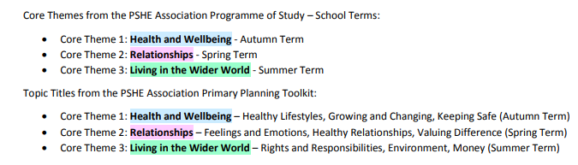
There are 3 core themes:

Managing Difficult Questions and Confidentiality
In PSHE pupils learn about personal safety and the law. Should a pupil make a disclosure to a member of staff this will be reported to a designated safeguarding lead and followed up in accordance with our disclosure procedures. Please see our Child Protection policy on the school website for further information.
All aspects of PSHE are underpinned by shared and understood ground rules with lessons being delivered in a safe and well-managed environment. To ensure the content and delivery of PSHE education is appropriate and relevant to our pupils we use simple baselines to ascertain what pupils already know, and what they would like to learn. Distancing techniques are used in PSHE education, which provide depersonalised examples which support children to explore what is being taught without sharing their own personal experiences in the lesson. Pupils are encouraged to ask questions and raise issues in a respectful and appropriate manner.
Some questions or issues raised may not be appropriately answered in whole class lessons and these will be followed up separately on an individual or group basis. A question box is available for pupils who do not feel confident to ask questions or wish to have a separate conversation with a member of staff. Given ease of access to the internet, children whose questions go unanswered may turn to inappropriate sources of information. Teachers will answer questions honestly, sensitively and in an age-appropriate manner, taking account of the school’s safeguarding responsibilities. Questions that are not appropriate for a whole-class response may be addressed individually or referred to parents where appropriate. Where a pupil has been withdrawn from designated sex education, staff will respond sensitively to questions relating to content from which the pupil has been withdrawn, without providing the withdrawn teaching.
We also respect that some questions are better addressed at home with parents/carers and the school will share information with parents/carers on an individual basis should the need arise.
Whilst it is vital to have trust and openness we cannot offer pupils complete confidentiality. Any disclosures or areas of concern will be followed up in accordance with our safeguarding procedures.
How delivery and content will be made accessible to all pupils including SEND
We are an inclusive school. As with all subject areas, delivery of PSHE is made to all pupils through high-quality, inclusive and adaptive teaching, which takes into account the learning needs of all the children in the classroom. This includes making appropriate adaptations, providing additional support where required and creating an inclusive learning environment that is sensitive to pupils’ individual learning, communication, emotional, social and economic needs. Pupils who receive 1:1 support will have access to support during PSHE lessons where appropriate to their needs. Lesson plans will take account of the differing needs of pupils with SEND however, the school recognises that not all pupils with identified special educational needs require the same level of support in PSHE as they may do in other core subjects.
Impact
- PSHE provision provides pupils with well-chosen opportunities and contexts to explore and embed new knowledge that can be used confidently in real life situations
- Pupils are able to form healthy, happy relationships with other children and adults and recognise the features of unhealthy relationships and have strategies to challenge negative behaviour of others and seek help when needed
- Pupils know how and when to ask for help and where to access support
- Pupils are well informed and recognise the risks they may encounter both on and off line and are able to make safe choices
- Pupils are enabled to take responsibility for their actions and understand the implications and consequences of their own decisions
- Pupils are well prepared for the next steps of their lives
- Pupils have the knowledge, skills and attributes to live healthy, happy lives
- Pupils understand and respect differences between themselves and others
5. Roles and Responsibilities
The Governing Body will approve the policy and hold the Headteacher to account for its implementation.
The Governing Body will ensure that:
- statutory Relationships Education and Health Education are provided for all pupils;
- teaching is accessible to pupils with SEND;
- curriculum content and teaching materials are consistent with statutory guidance;
- parents receive clear information about content, resources, external providers and the right to request withdrawal from designated sex education; and
- appropriate arrangements are in place to monitor the quality and effectiveness of provision.
The Headteacher is responsible for ensuring PSHE is taught consistently across the school and for managing requests with regards to the parental right to withdraw from non-statutory Sex Education.
The PSHE lead is responsible for leading and managing the subject. Teachers are responsible for delivering PSHE.
Pupils are expected to engage fully with PSHE provision and treat others with respect.
6. Working with outside agencies and visiting speakers
The school may use appropriately qualified external agencies and visiting speakers to enhance its PSHE and RSHE provision. External visitors will supplement, rather than replace, teaching by school staff. The school remains responsible for the content, quality and delivery of all provision.
Before an external visitor delivers a session, the school will:
- check the visitor’s identity, experience, credentials and suitability;
- review the proposed lesson plan and all teaching materials;
- ensure that the content is accurate, balanced, age-appropriate, accessible and consistent with this policy and the school’s values;
- consider whether the material meets the needs of pupils, including pupils with SEND;
- ensure that the content is politically impartial and does not promote partisan views;
- agree how questions, confidentiality, disclosures and safeguarding concerns will be managed; and
- make relevant materials available for parents to view on request.
A member of school staff will remain present and involved during sessions delivered by an external visitor. Any safeguarding concern will be managed in accordance with the school’s Child Protection Policy and agreed procedures.
7. Monitoring, evaluation and training
- PSHE provision will be monitored and evaluated by the PSHE lead, SLT and Governors in line with the monitoring cycle agreed by the school .The PSHE policy will be reviewed annually.
- To ensure staff are confident to deliver all aspects of the PSHE curriculum, access to online, in-school, local and national training will be made available and in accordance with the school’s CPD programme for staff development
8. Working with parents
It is vital that parents and carers know what is being taught and how to support their child/children. The PSHE curriculum overview is published on the school website along with the PSHE policy, and RSE policy. Appendix 1 shows what is being taught as part of the rolling programme in Key Stage 1 & 2. Parents will be given clear information about what is taught and when. The school will show parents a representative sample of the RSHE resources it plans to use, and parents may request to view all curriculum materials used to teach RSHE. Copyright restrictions may affect how materials are shared or copied but will not be used as a reason to prevent parents from viewing them. Parents do not have a right to veto curriculum content.
We have an open door policy for any parents/carers who wish to find out more about our PSHE provision. We consult with parents, carers and the wider community through questionnaires and specific parent workshops/meetings. We understand that parents and carers may wish to approach the school to access help with concerns they may have about their child and where they can go to obtain further support.
Our PSHE policy and PSHE curriculum overview can be found on the school website. We welcome and encourage parents and carers to make an appointment with the class teacher or the Headteacher to discuss any aspect of the PSHE curriculum or to raise any concerns they may have regarding this vital area of education.
Parents do not have the right to withdraw their child from statutory Relationships Education, Health Education or content taught as part of the national curriculum for science. Parents have the right to request that their child is withdrawn only from designated non-statutory sex education lessons. The procedure for making and managing a request is set out in the school’s Sex Education Policy. The school strongly recommends that pupils receive the full PSHE curriculum.
This policy and the PSHE curriculum overview are published on the school website. A paper copy will be provided free of charge on request.
Useful information for parents
We have a designated area of the School website signposting to trusted external websites e.g. Parent Zone, the NSPCC and CEOP Education.
The DfE guide for parents is here
https://assets.publishing.service.gov.uk/government/uploads/system/uploads/attachment_data/file/812593/RSE_primary_schools_guide_for_parents.pdf
9. Linked policies
Child Protection
Behaviour Policy (inc anti bullying)
Relationships Education Policy
Sex Education Policy
Mental Health and Wellbeing Policy
SEND Policy
Cross Curricular links
Cross Curricular links will also be made between PSHE and other curriculum areas as appropriate, including:
- RE: religious and moral beliefs, values and practices that underpin and influence personal and social issues and relationships
- ENGLISH: skills in enquiry and communication, stories that illustrate aspects of personal and social development.
- NUMERACY: aspects of financial capability, counting and sharing
- SCIENCE: drugs (including medicines) sex education, health, safety and the environment
- D&T: health and safety, healthy eating
- HISTORY: reasons for and results of historical events, situations and changes
- GEOGRAPHY: topical issues concerning the environment; GLOBAL CITIZENSHIP
- ART/DT: reflecting on and responding to ideas and experiences communicated through works of art, craft and design from different times and cultures
- MUSIC: making the most of abilities in playing or singing, issues of cultural diversity, their value and their expression
- PE: teaching and learning about health and safety, development of personal and social skills through team and individual activities, games and sports.
PSHE will further be supported through discrete activities and school events.

Appendix 1 PSHE Long Term Plan
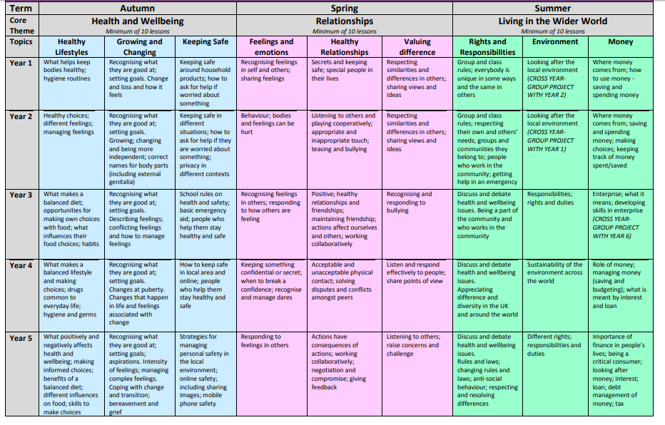
The Curriculum framework whole school overview gives a brief summary or ‘at a glance view’ of what is taught under the core theme and topic title, in each term, for each year group, across the school. It also provides a quick and simple way to view the progression of learning throughout the primary phase. Due to year groups being mixed, some content is taught separately or collectively.

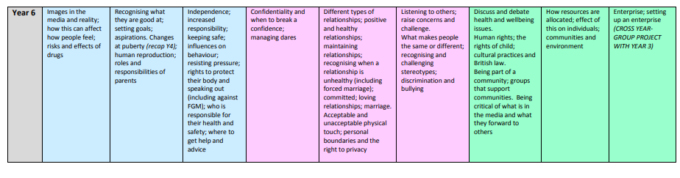

Appendix 2
Ground rules for PSHE lessons

Ground rules
Ground rules help to minimise inappropriate and unintended disclosures and comments of a negative nature made towards other students whether intentional or not. Such ground rules support broader class rules and the school’s behaviour policy. In order for ground rules to be effective, they should be developed and agreed with the pupils themselves, rather than given or imposed by the teacher. The content of PSHE is wide and varied and needs to be age-appropriate. Pupils need to be taught how to ask questions, explore their views and attitudes in a classroom situation, and to understand what to do if they need further support.

Ideas for ground rules
Shared agreement
• We join in and ask questions if we want to
• We make sure that everybody feels listened to
• We make sure everybody feels ok – we don’t put people down
• We use the correct vocabulary when possible; if we are unsure, we ask the teacher
• We do not name names
• We know we can ask for further help or advice if we want and after the lesson too

Rights and responsibilities
• Everybody has the right to feel listened to
• Everybody has the right to join in and speak if they want to
• We have the responsibility to ensure people do not feel judged or ‘put down’
• We have a responsibility to use the correct vocabulary so as not to cause offence
• We respect one another’s privacy and do not repeat personal information shared during a lesson. However, we understand that we must tell a trusted adult if we are worried that someone may be unsafe or at risk of harm.
• Everybody has the right to seek help or advice if they want to
Appendix 3
DFE Information Guidance and Curriculum Content
Relationships
https://www.gov.uk/government/publications/relationships-education-relationships-and-sex-education-rse-and-health-education/relationships-education-primary

Health and wellbeing: primary statutory content
https://www.gov.uk/government/publications/relationships-education-relationships-and-sex-education-rse-and-health-education/physical-health-and-mental-wellbeing-primary-and-secondary

DfE Guide for parents
https://assets.publishing.service.gov.uk/government/uploads/system/uploads/attachment_data/file/812593/RSE_primary_schools_guide_for_parents.pdf

