Class 2 English Long-Term Plan
Cycle B 2025-2026
Autumn Term | Autumn Term | Spring Term | Spring Term | Summer Term | Summer Term
Colour Chaos | Explore and Investigate | Where I live |  | Our World | All Sew UP
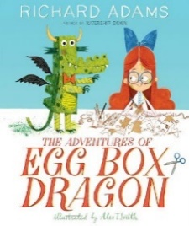  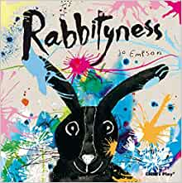  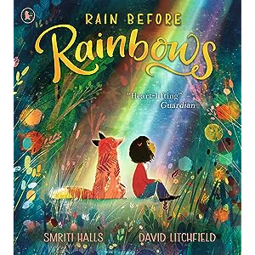 | 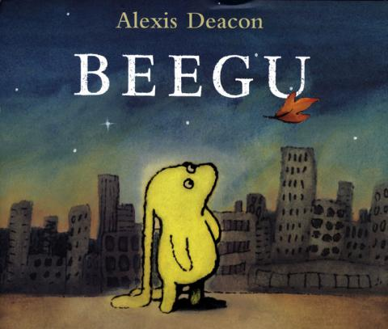 | 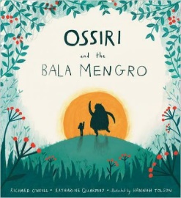 | 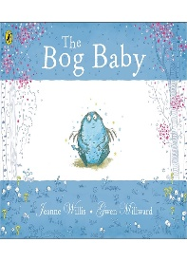 | 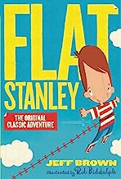  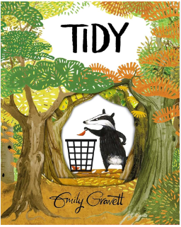 | 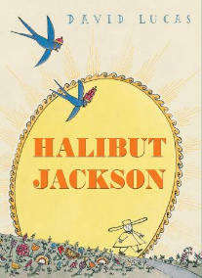
Purpose:  Entertain | Purpose:  Entertain/ Inform | Purpose:  Entertain/Inform | Purpose:  Entertain/Inform | Purpose:  Entertain/Inform | Purpose:  Entertain
Written Outcomes:  Speech/Thought Bubbles  Personal Narrative  Letters  Invitations  Instructions  Poetry | Written Outcomes:  Character/Setting Descriptions  Postcards  Letters  Information Posters | Written Outcomes:  Information Poster / Text  Persuasive Letter | Written Outcomes:  Character/Setting Descriptions  Letters  Narrative  Poetry | Written Outcomes:  Non-Chronological Report  Newspaper Article  Letters  Postcards | Written Outcomes:  Diary  Descriptions
Year 1 Planning Writing and Editing
To say out loud what they are going to write about.
To compose a sentence orally before writing it
To sequence sentences to form short narratives
To discuss what they have written with the teacher or other pupils.
To reread their writing to check that it makes sense and to independently begin to make changes.
To read their writing aloud clearly enough to be heard by their peers and the teacher.
To use adjectives to describe.

Year 2 Planning Writing and Editing
To write narratives about personal experiences and those of others (real and fictional).
To write about real events. To write simple poetry.
To plan what they are going to write about, including writing down ideas and/or key words and new vocabulary
To encapsulate what they want to say, sentence by sentence.
To make simple additions, revisions and corrections to their own writing by evaluating their writing with the teacher and other pupils.
To reread to check that their writing makes sense and that the correct tense is used throughout.
To proofread to check for errors in spelling,
grammar and punctuation (e.g. to check that the ends of sentences are punctuated correctly.)

Year 1 Awareness of Audience, Purpose and Structure
To use a number of simple features of different text types and to make relevant choices about subject matter and appropriate vocabulary choices.
To start to engage readers by using adjectives to describe.
Year 2
To write for different purposes with an awareness of an increased amount of fiction and non-fiction structures.
To use new vocabulary from their reading, their discussions about it (one- to-one and as a whole class) and from their wider experiences.
To read aloud what they have written with appropriate intonation to make the meaning clear.
Year 1 Sentence Construction and Tenses
To use simple sentence structures.
Year 2
To use the present tense and the past tense mostly correctly and consistently.
To form sentences with different forms: statement, question, exclamation, command.
To use some features of written Standard English.
Year 1 Use of Phrases and Clauses
To use the joining word (conjunction) ‘and’ to link ideas and sentences.
To begin to form simple compo¬¬und sentences.
Year 2
To using co-ordination (or/and/but).
To use some subordination (when/if/ that/because).
To use expanded noun phrases to describe and specify (e.g. the blue butterfly).
Year 1 Punctuation
To use capital letters for names, places, the days of the week and the personal pronoun ‘I’.
To use finger spaces.
To use full stops to end sentences.
To begin to use question marks and exclamation marks.

Year 1 Punctuation
To use capital letters for names, places, the days of the week and the personal pronoun ‘I’.
To use finger spaces.
To use full stops to end sentences.
To begin to use question marks and exclamation marks.
Year 2
To use the full range of punctuation taught at key stage 1 mostly correctly including:
capital letters, full stops, question marks and exclamation marks;
commas to separate lists;
Apostrophes to mark singular possession and contractions.

Key Vocabulary
Year 1
To recognise and use the terms letter, capital letter, word, singular, plural, sentence, punctuation, full stop, question mark and exclamation mark.
Year 2
To recognise and use the terms noun, noun phrase, statement, question, exclamation, command, compound, suffix, adjective, adverb, verb, present tense, past tense, apostrophe and comma.
Handwriting
Year 1
Pupils should be taught to:
To write lower case and capital letters in the correct direction, starting and finishing in the right place with a good level of consistency.
To understand which letters belong to which handwriting ‘families’ (i.e. letters that are formed
in similar ways) and to practise these.

Year 2
To write capital letters and digits of the correct size, orientation and relationship to one another and to lower case letters
To form lower case letters of the correct size, relative to one another
To use spacing between words that reflects the size of the letters
To begin to use the diagonal and horizontal strokes needed to join letters.

Class 2 English Long-Term Plan (Cycle A)
Cycle A 2026-2027
Autumn Term | Autumn Term | Spring Term | Spring Term | Summer Term | Summer Term
Being Me | A Wild Adventure | Exploring China | Toys | Let’s Go The Seaside
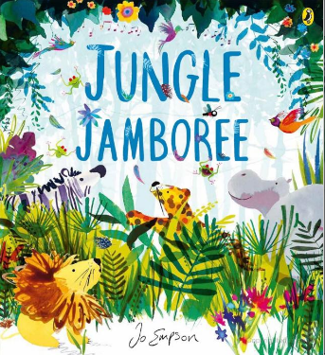 | 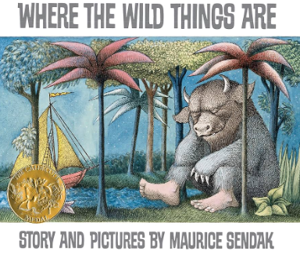 | 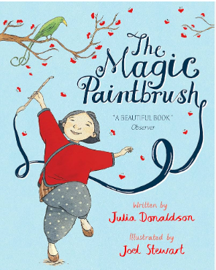 | 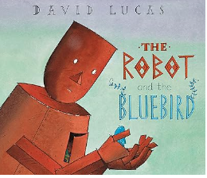 | 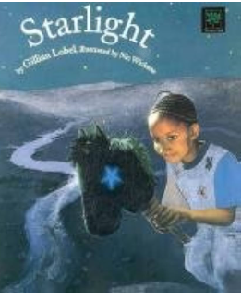 | TBC
Purpose:  Entertain | Purpose:  Entertain | Purpose:  Entertain | Purpose:  Entertain | Purpose:  Entertain | Purpose:  Inform/Entertain
Written Outcomes:  Speech/Thought Bubbles  Personal Narrative  Letters  Invitations  Instructions | Written Outcomes:  Character/Setting Descriptions  Instructions | Written Outcomes:  Instructions  Information Poster / Text  Persuasive Letter | Written Outcomes:  Character/Setting Descriptions  Letters  Narrative  Poetry | Written Outcomes:  Non-Chronological Report  Newspaper Article  Letters  Postcards | Written Outcomes:  Diary  Descriptions
Year 1 Awareness of Audience, Purpose and Structure
To use a number of simple features of different text types and to make relevant choices about subject matter and appropriate vocabulary choices.
To start to engage readers by using adjectives to describe.
Year 2
To write for different purposes with an awareness of an increased amount of fiction and non-fiction structures.
To use new vocabulary from their reading, their discussions about it (one- to-one and as a whole class) and from their wider experiences.
To read aloud what they have written with appropriate intonation to make the meaning clear.
Year 1 Sentence Construction and Tenses
To use simple sentence structures.
Year 2
To use the present tense and the past tense mostly correctly and consistently.
To form sentences with different forms: statement, question, exclamation, command.
To use some features of written Standard English.
Year 1 Use of Phrases and Clauses
To use the joining word (conjunction) ‘and’ to link ideas and sentences.
To begin to form simple compo¬¬und sentences.
Year 2
To using co-ordination (or/and/but).
To use some subordination (when/if/ that/because).
To use expanded noun phrases to describe and specify (e.g. the blue butterfly).
Year 1 Punctuation
To use capital letters for names, places, the days of the week and the personal pronoun ‘I’.
To use finger spaces.
To use full stops to end sentences.
To begin to use question marks and exclamation marks.

Year 1 Punctuation
To use capital letters for names, places, the days of the week and the personal pronoun ‘I’.
To use finger spaces.
To use full stops to end sentences.
To begin to use question marks and exclamation marks.
Year 2
To use the full range of punctuation taught at key stage 1 mostly correctly including:
capital letters, full stops, question marks and exclamation marks;
commas to separate lists;
Apostrophes to mark singular possession and contractions.

Key Vocabulary
Year 1
To recognise and use the terms letter, capital letter, word, singular, plural, sentence, punctuation, full stop, question mark and exclamation mark.
Year 2
To recognise and use the terms noun, noun phrase, statement, question, exclamation, command, compound, suffix, adjective, adverb, verb, present tense, past tense, apostrophe and comma.
Handwriting
Year 1
Pupils should be taught to:
To write lower case and capital letters in the correct direction, starting and finishing in the right place with a good level of consistency.
To understand which letters belong to which handwriting ‘families’ (i.e. letters that are formed
in similar ways) and to practise these.

Year 2
To write capital letters and digits of the correct size, orientation and relationship to one another and to lower case letters
To form lower case letters of the correct size, relative to one another
To use spacing between words that reflects the size of the letters
To begin to use the diagonal and horizontal strokes needed to join letters.

