Class 1 weekly update

(2nd - 6th October 2023)

Our learning theme this week is: Our Bodies
Book of the week: Funny Bones
Class 1’s performance at the Celebration Assembly is now available to watch on Evidence Me.
The children were all fabulous and we are very proud of them!
Nursery

- We are going to be listening carefully to Funny Bones and talking about Goldilocks.
We are also going to continue learning all about 2D shapes and making shape collage pictures! You could play guess the shape? Hide pictures of 2D shapes behind a book revealing only a corner then guess what shape it is!
Reception

- In phonics we will be learning the sounds: ck, e, u, r. We will also be learning to recognise the tricky word ‘to’ and ‘the’. How many cvc words can you write using the sounds we have learnt so far? s a t i p n m d g o c k
- In our Maths carpet time this week we will be looking at counting and the term ‘how many’ with numbers to 5. How many of each natural object can you see?
Reminders
Thursday 5th October 2.15pm – Phonics and Reading workshop EYFS and Key Stage 1
Friday 6th October 2.30pm – Maths Mastery workshop
Makaton sign of the week
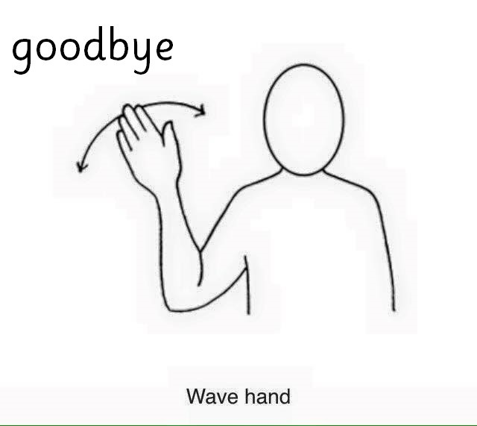
Recycling for junk modelling
We would appreciate any of your weekly recycling; kitchen tube rolls, clean yogurt pots, milk tops, cereal boxes, chocolate box inserts & plastic fruit containers for the children to design and invent with in our creative area! Thank you.

