Class 1 weekly update
(30th October – 3rd November 2023)
Welcome back and we hope you all had an enjoyable and restful Half Term break.
Our learning theme this week is: Halloween/Bonfire Night
Book of the week: Room on the Broom
Collective worship: We will continuing our learning about Adam and Eve and the Garden of Eden and we will learn the song ‘Our God is a Great Big God’
Makaton Signs of the week: Light and dark
Nursery
- We will be creating firework art using our finger prints.
- In Maths we will be sorting bears by colour.
- In our Phonics, we will be listening carefully to a story and finding instruments which match different environmental sounds.
Can you retell the story of Little Red Riding Hood to your grown up at home?
Reception
- In Phonics this week we will be recapping everything we have learnt so far including our sounds and tricky words.
- In Maths we will be comparing objects by size, using the words 'bigger' and 'smaller' and comparing sets of objects to see which has 'more' and which has 'less'.
Are there more pumpkins or less pumpkins?
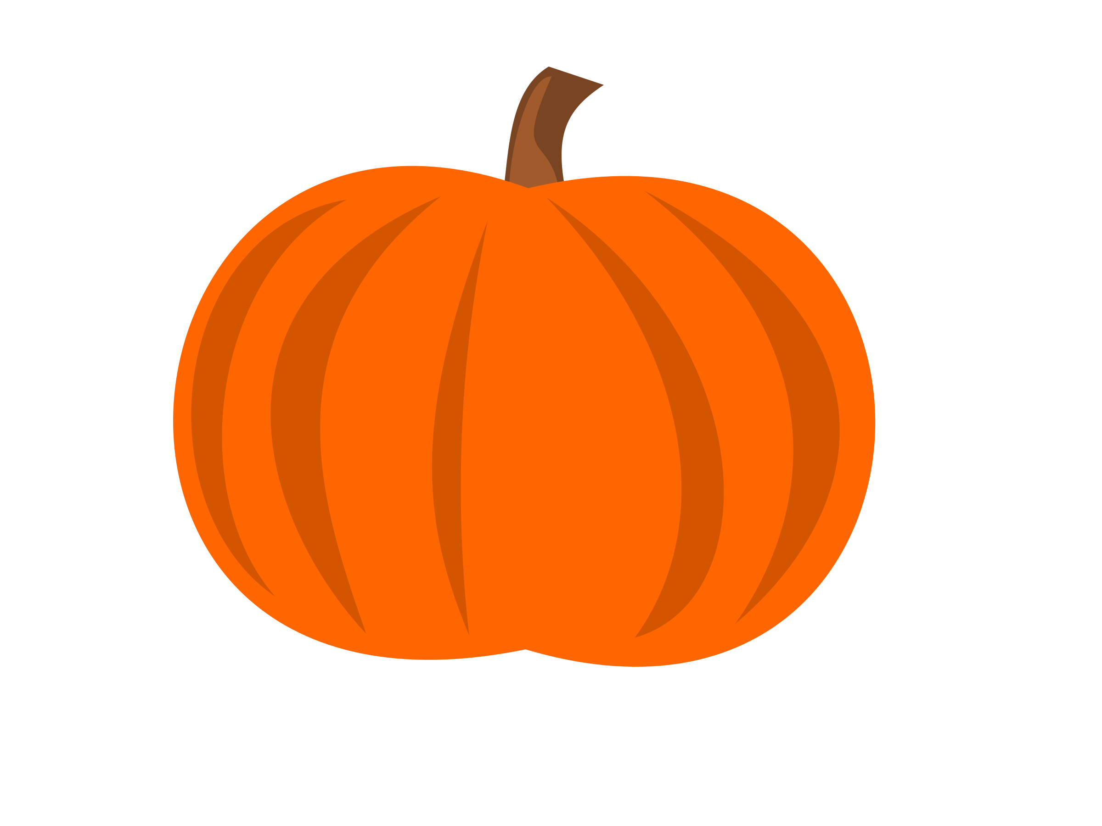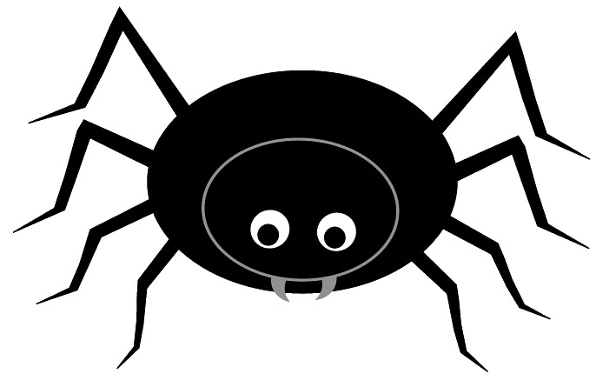
- We will be making firework art as well as talking about firework safety.
Thank you to those who have returned their Autumn Treasures bags. Please remember to bring them in this week if you haven't already done so!

