

Class 1 weekly update

29th April – 3rd May

**Our learning theme this week is:**

The life cycle of a sunflower

**Book of the week:**

‘The Tiny Seed’ by Eric Carle

**We are enjoying watching our caterpillars grow – they are getting bigger every day! We also love watching the mummy bird incubating her nest as well on our bird-cam. Hopefully we will see some chicks hatch in the coming weeks.**

Nursery

* We will be learning the rhyme ‘A little seed’ and the Makaton sign for flower. Can you show your grown up this at home?
* In our maths time we will be comparing the size of different objects, using vocabulary such as ‘bigger’, ‘smaller’, ‘large’ and ‘tiny’.
* In our phonics time we will be looking at words that begin with the same letter.

Which one of these pictures is the odd one out? Listen to their first sound.

  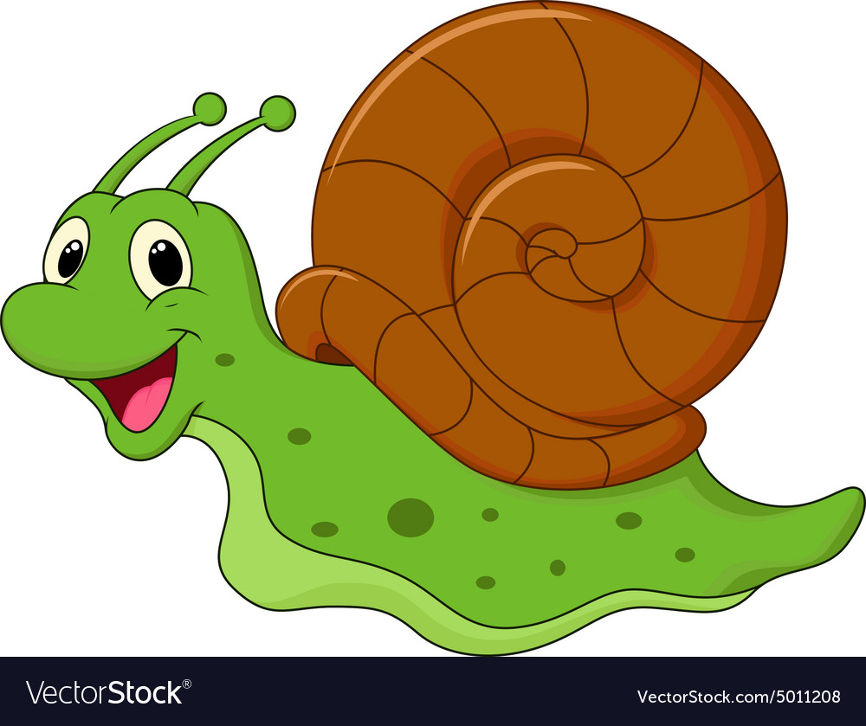

Reception

* In Mrs Deane’s/Miss Atkins phonics group, we have now finished learning all of our new sounds so this week we will be recapping the Level 3 sounds. In Mrs Sim’s group, we will be practising reading words with more than one syllable, e.g. windmill, sunset.
* In maths, we will be continuing our work on 3D shapes as well as looking at number bonds to 5.

Can you get 5 objects and look at all of the different ways you can put these into two groups?

**Reception parents: Please remember that your child’s reading book and reading record should be in their bag every day as we try to listen to the children read as frequently as possible thorughout the week. Many thanks!**