**Cadmore End News . February 2021**

‘Remember when we used to have “ Proper” Winters like this ? This was taken in December 2010. Having said that congratulations to whoever built the spectacular snowman on the Cricket Field after recent snow. ( Jan 24th )

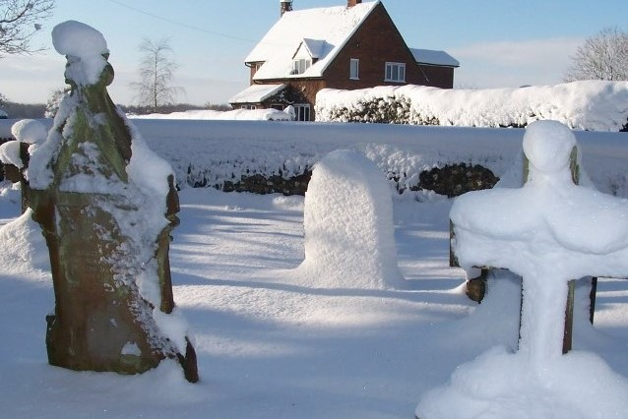

**“One Can” Donations;**

Many thanks to all who continue to generously donate to the One Can Collections ( collected weekly on **Fridays** a.mfrom church porch ). Having witnessed the organisation at first hand at the distribution point in High Wycombe it is a highly impressive operation staffed entirely by volunteers. These same volunteers continue to distribute to those in need all day, 5 days a week, throughout High Wycombe.

**Vaccines Update.**

Many of us in the Village have now received their first vaccination jab, mostly at Lunar House in Marlow. Some at Adams Park. High Wycombe. ( do bear in mind how many of us are in the “ qualifying” age bracket … ). From all accounts this has been…and still is… a most impressive, well organised operation.

*THE COVID BEAST IS STILL OUT THERE…EVEN IF YOU HAVE HAD YOUR ‘JAB’COVER UP AND MAINTAIN THE SPACE.*

**Health warning**; “Scientists have now confirmed that women who have put on weight during lockdown

are likely to live longer than the men who mention it.”

**Surgery of hedge behind Blacksmith’s Cottage.**

As many will have no doubt have noticed (?) some serious renovation has been carried out on the hedge behind Blacksmith’s Cottage, together with a v. impressive bonfire ( all traces since removed and little or no leftovers discernible )

From all reports this has made a huge difference to the amount of light in both Blacksmith’s Cottage and near neighbours.

**Hope for all “Non Gardeners”** Sightings of some of Britain’s best- loved garden birds have fallen according to a recent report in The Times because of “overly tidy gardening”. “That’ll be why I spotted a nightjar, 3 Kestrels and a white-tailed eagle in mine” says Giles Coren .

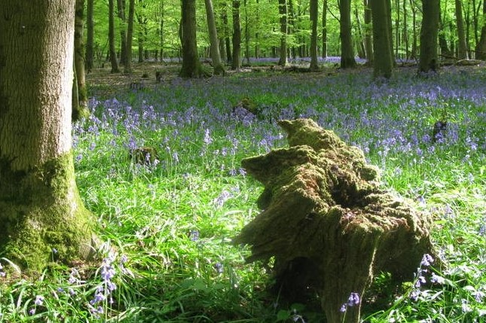If like many of us you are suffering from Cabin Fever and the effects of Lock Down do not despair. Hanger Wood will soon look like this again

Cadmore End PCC- website “church.cadmoreend.org.uk”.

Email church@cadmoreend.org.uk Village Hall website “cadmoreendvillagehall.co.uk”