Class 3 English Long-Term Plan
Cycle B 2025=2026 Cycle A 2026-2027

Cycle B | Autumn 1 |  | Autumn 2 | Spring 1 | Spring 2 | Summer 1 | Summer 2
Cross Curricular  Links |  | Ancient Egypt | Romans | Rainforests | Crime and Punishment | Extreme Earth | Land Use
 |  | 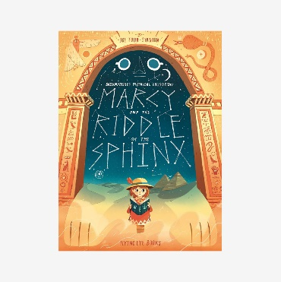  Marcy and the Riddle Sphinx  By Joe Todd-Stanton | 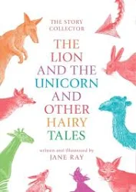  The Lion and the Unicorn and Other Hairy Tales by Jane Ray | 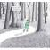  Into The Forest by Anthony Browne | 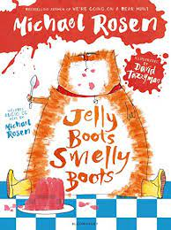Jelly Boots, Smelly Boots  Michael Rosen, David Tazzyman | 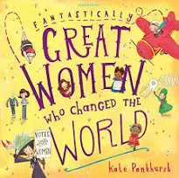Fantastically Great Women Who Changed the World Kate Pankhurst | 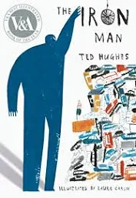The Iron Man  Ted Hughes, Laura Carlin
Purpose |  | Inform, explain | Entertain, persuade | Entertain | Entertain | Inform, persuade | Persuade, inform
Written Outcomes |  | Information Writing Explanatory Writing Referential Writing | Writing in Role Persuasive Writing Narrative | Advisory Note Playscript Narrative Retelling | Poetry in a range of forms | Biography Newspaper Report Persuasive Speech | Recounts Persuasive Letter Radio/TV Reports
Reading: Experience, Knowledge, Skills and Strategies |  | Responding to Illustration Visualise  Empathise  Ask, answer and evaluate questions Make predictions  Looking at Language  Develop inference and deduction Character comparison  Develop personal, critical and evaluative response  Storymapping and narrative structure | Visualise  Make predictions and summarise Develop inference and deduction Develop breadth of reading Develop knowledge of narrative structure and storytelling devices Form intertextual links  Rereading  Close reading  Develop fluency through performance Looking at language | Responding to illustration  Develop fluency through performance Make predictions  Develop inference and deductions Make personal connections  Form intertextual links Empathise  Link texts and illustrations Storymapping and narrative structure | Develop fluency with rhythm and rhyme and preparing for performance  Visualise  Make personal connections  Develop personal, critical and evaluative response  Empathise  Looking at language Text marking  Close reading and rereading | Form intertextual links Looking at Language Develop breadth of reading  Skim, scan, note-take and summarise Develop inference and deduction Empathise  Rereading and close reading  Develop personal, critical and evaluative response  Consider authorial intent | Responding to illustration Looking at language Visualise  Character comparison Scanning and close reading  Develop fluency through performance Develop inference and deduction Develop personal, critical and evaluative response  Build reading stamina Form intertextual links
Vocabulary, Grammar, Punctuation (and Spelling) and Extended Language Competency |  | Expanding noun phrases (by modifying adjectives, nouns and prepositional phrases)  Conjunctions, adverbs and prepositions to express time, place and cause Fronted adverbial  Use of determiners and definite article Active and passive voice  Adverbs or modal verbs for degree of possibility  Direct speech punctuation Exploring word families | Progressive form of verbs to mark actions in progress  Expanding noun phrases (by modifying adjectives, nouns and prepositional phrases)  Conjunctions, adverbs and prepositions to expressing time, place and cause Fronted Adverbial  Apostrophes to mark plural possession Adverbs or modal verbs for degrees of possibility  Subjunctive form  Direct Speech punctuation Functional sentence structure | Simple first person, past-tense narrative Expanding noun phrases (by modifying adjectives, nouns and prepositional phrases)  Conjunctions, adverbs and prepositions to expressing time, place and cause Fronted Adverbial  Pronoun to aid cohesion Comparatives and Superlatives Direct speech punctuation Contractions  Relative clause | Figurative language, including similes and metaphors  Visual patterns in rhyming words, linking sound and print – onset and rime, assonance, alliteration, onomatopoeia, rhyme  Opportunity to revise consonant clusters and complex code  Explore syllabification and morphology for spelling  Investigate word families  Compare standard English and spoken forms Expanding noun phrases (by modifying adjectives, nouns and prepositional phrases) | Expanding noun phrases (by modifying adjectives, nouns, prepositional phrases) Conjunctions, adverbs and prepositions to expressing time, place and cause Fronted Adverbial  Paragraphs to organise ideas Pronouns to aid cohesion Mixture of simple, complex and  compound sentences to support clarity  Headings and subheadings Direct speech punctuation  Punctuation for effect and clarity: question mark, exclamation mark, comma, dash, ellipsis | Figurative language incl. metaphor, simile, personification, onomatopoeia… Comparatives and superlatives  Direct speech punctuation  Expanding noun phrases (by modifying adjectives, nouns, prepositional phrases) Conjunctions, adverbs and prepositions to expressing time, place and cause Fronted Adverbial  Exploring word families  Pronouns for cohesion and to avoid repetition  Paragraphs to organise ideas Active and passive voice

Cycle A | Autumn 1 | Autumn 2 | Spring 1 | Spring 2 | Summer 1 | Summer 2
Cross Curricular Links | Stone Age | All around the world | All Around The World | The Saxons and Scots | The Vikings and Saxons | Somewhere to Settle
 | 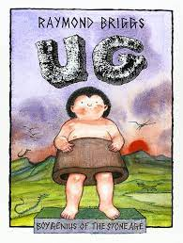 Ug: Boy Genius of the Stone Age  Raymond Briggs | 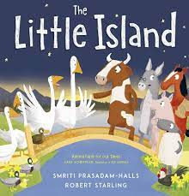 The Little Island  Smriti Halls, Robert Starling | 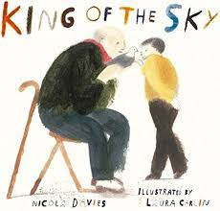 King of the Sky  Nicola Davies, Laura Carlin | 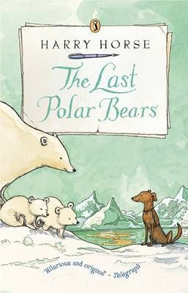  The Last Polar Bears by Harry Horse | 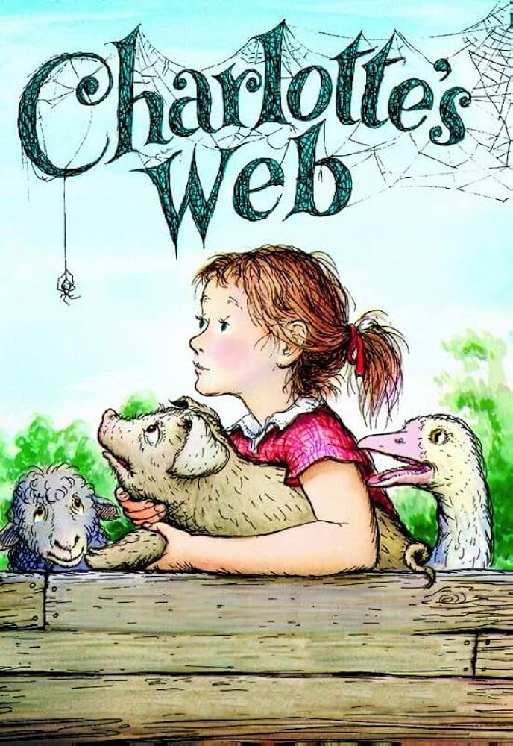  Charlotte’s Web by E.B White
Purpose | Inform, persuade | Persuade, inform | Describe, persuade | Entertain | Entertain, describe | Inform, describe
Written Outcomes | Procedural Persuasive Speech  Non-Chronological Report | Letter to MP Diary Entry  Rescue Plan and Instructions | Descriptive Writing Balanced Argument Newspaper Report | Poetry in a range of forms | Collaborative free verse poetry Narrative Element - Descriptive Passage | Writing in Role Narrative Descriptions Autobiography
Reading: Experience, Knowledge, Skills and Strategies | Responding to illustration Make Predictions  Make personal connections Develop inference and deduction  Develop personal, critical and evaluative response  Looking at language and structure Develop visual literacy  Form intertextual links Empathise  Develop breadth of reading | Revise the complex code Link reading and spelling Visualise  Link text and illustrations Close reading and scanning Looking at language  Make predictions and summarise Empathise  Develop inference and deduction Develop personal, critical and evaluative response | Responding to illustration Visualise  Make predictions  Develop inference and deduction Form intertextual links Rereading and close reading  Looking at language and authorial intent Make personal connections  Empathise  Develop visual literacy  Ask, answer and evaluate questions | Revise complex code – link spelling and reading  Support fluency with rhythm and rhyme Responding to illustration  Develop fluency through performance Make predictions  Develop inference and deduction Form intertextual links  Make personal connections Close reading and rereading Looking at language | Visualise  Develop personal, evaluative and critical response  Form intertextual links Make personal connections  Looking at language and authorial intent Develop inference and deduction  Make predictions Empathise  Develop fluency through performance | Visualise Empathise  Ask, answer and evaluate questions Make predictions  Looking at Language  Develop inference and deduction Develop personal, critical and evaluative response  Develop breadth of reading  Develop fluency through performance Build reading stamina
Vocabulary, Grammar, Punctuation (and Spelling) and Extended Language Competency | Past tense, including progressive Direct and reported speech in different forms  Functional sentence structure, including rhetorical questions, exclamations Apostrophe for contractions Conjunctions, adverbs and prepositions to express time, place and cause Compare standard English and spoken forms  Expanding noun phrases (by modifying adjectives, nouns and prepositional phrases) | Past tense consistency, including progressive and present perfect Expanding noun phrases (by modifying adjectives, nouns and prepositional phrases)  Conjunctions, adverbs and prepositions to express time, place and cause Figurative language including metaphor, personification and simile  Use of determiners and definite article Active and passive voice  Adverbs or modal verbs for degree of possibility | Expanding noun phrases (by modifying adjectives, nouns and prepositional phrases)  Conjunctions, adverbs and prepositions to expressing time, place and cause Fronted Adverbial  Past and present perfect tense Direct speech with punctuation Figurative language including simile, personification  Alliteration  Adverbs or modal verbs for degrees of possibility  Pronoun to aid cohesion | Deliberately archaic vocabulary and language structures  Compare standard English and spoken forms Apostrophe for abbreviations  Invented spelling and word play Onomatopoeia  Figurative Language including simile, metaphor and personification Investigating language features: Homophones, homonyms, alliteration, assonance, onset and rime  Expanding noun phrases (by modifying adjectives, nouns and prepositional phrase) Conjunctions, adverbs and prepositions to expressing time, place and cause | Present continuous combined with simple past tense verb choices Progressive form of verbs to mark actions in progress  Expanding noun phrases (by modifying adjectives, nouns and prepositional phrases)  Conjunctions, adverbs and prepositions to expressing time, place and cause Fronted Adverbial  Pronoun to aid cohesion Comparatives and Superlatives Alliteration | Expanding noun phrases (by modifying adjectives, nouns and prepositional phrases)  Conjunctions, adverbs and prepositions to express time, place and cause Fronted adverbial marked by comma Brackets to demarcate parenthesis Direct speech punctuation  Functional sentence structure, including questions, commands and exclamations Active and passive voice  Figurative language  Compare standard and spoken forms

