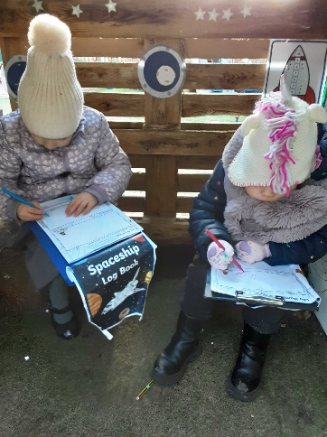
We are having a fantastic term in Class 1 learning all about space! We have learnt lots of ‘Wow’ words including ‘solar system’, ‘gravity’, and ‘launch’. We have made rockets out of cardboard tubes; experimented with colour mixing to represent the different colours of the sky throughout the day; made moon dough by mixing oil and cornflour; explored how to make shadows using torches; and have made different planets by collaging on paper plates. We have also enjoyed role playing astronauts and pretending to move with no gravity! In our PE lessons we have been working on ball skills and learning about to move a ball around a set of cones using our feet. 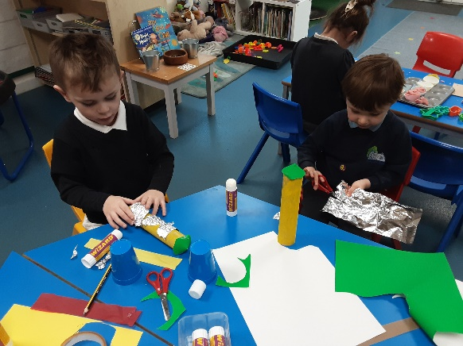

In maths, Reception have been learning about the composition of 5 using part-part-whole models. We have also been looking at 4 sided shapes and making shape pictures out of these. In nursery we have been learning about height, using the vocabulary ‘taller’ and ‘shorter’. We have also been combining two groups of objects to see how many there are all together.
We have enjoyed welcoming some new faces to Nursery this term and are so proud at how well the children have settled in. New friendships are blossoming and everyone is learning to share and take turns fairly.
