Class 4 English Long-Term Plan
Cycle B 2025-2026Cycle A 2026-2027
Cadmore End Class 4 Cycle B
Autumn Term | Autumn Term | Spring Term | Spring Term | Summer Term | Summer Term
Scientists and Inventors  Black History Month | Earth and Space | The Amazing Americas |  | Exploring Eastern Europe | British History
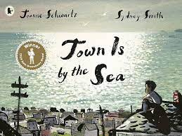  Town is by the Sea  Joanne Schwartz, Sydney Smith | 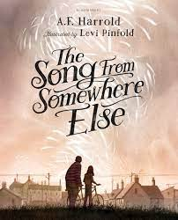  The Song from Somewhere Else  A F Harrold, Levi Pinfold | 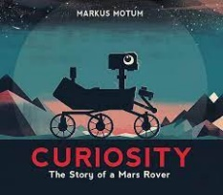  Curiosity:  The Story of a Mars Rover  Markus Motum (sequence pending) | 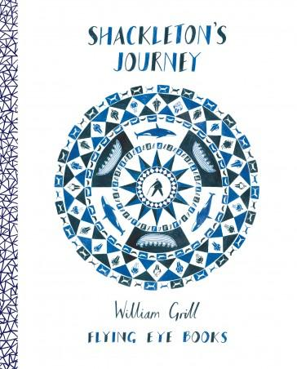  Shackleton’s Journey  Willian Grill | 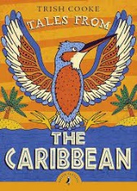  Tales from the Caribbean  Trish Cooke, Joe Lillington | 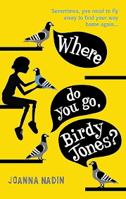  Where Do You Go, Birdy Jones?  Joanna Nadin
Purpose: Inform | Purpose: Entertain, inform | Purpose: Entertain, inform | Purpose: Inform, entertain | Purpose: Inform | Purpose: Entertain
Written Outcomes:  (Auto)biographies  Writing in role  Referential write-up of research | Written Outcomes:  Diaries & letters Character description Narrative | Written Outcomes:  Documentary script Research reports | Written Outcomes: Drawing and annotating ♣ Note writing in role as character ♣ Reading journals ♣ Text marking ♣ Story mapping ♣ Character description ♣ List poetry ♣ Letter writing ♣ Instructions ♣ Log writing ♣ Newspaper reports ♣ Speeches ♣ Recount ♣ Quote | Written Outcomes:  Playscript  Oral Storytelling Narrative: Folk Tales | Written Outcomes:  Information writing  Writing in role  Personal writing about transition
Grammar overview:  First person narrative voice Tense choices  Adverbials of time, place & number Prepositional phrases  Punctuation for effect, clarity & cohesion Semi-colon, colon and dash to mark clauses/in lists  Alliteration  Verb prefixes (e.g., dis-, de-, mis-, re-) Repetition for impact  Synonyms & antonyms  Range of layout devices (e.g., headings, columns, tables) | Grammar overview:  Adverbials of time, place & number Exploring word families  Formation of verbs using suffixes (-ate, - ise, -ify)  Brackets, dashes or commas to indicate parenthesis  Passive and active voice  Semi-colon, colon and dash to mark clauses/in lists  Adverbs or modal verbs for degrees of possibility  Devices to build cohesion Explore levels of formality | Grammar overview:  Non-fiction explanatory voice  Verb prefixes (e.g., dis-, de-, mis-, re-) Relative clauses  Pronoun to aid cohesion Commas & parenthesis to clarify  Adverbials of time, place & number Adverbs or modal verbs for degrees of possibility  Paragraphs to organise ideas Subheadings to aid presentation Brackets, dashes or commas to indicate parenthesis  Explore levels of formality | Grammar overview:  Tense choices Hyphens to avoidambiguity Exploring language&meaning play Explore levels of formality Compare standard English forms and spoken forms Expression & empathetic language Figurative language, including metaphor, simile, personification Punctuation for effect, clarity & cohesion Synonyms & antonyms | Grammar overview:  Compare standard English forms and spoken forms, and features associated with the Caribbean islands  Traditional Tale voice  Figurative language, including metaphor, simile, personification  Explore levels of formality  Inverted commas to punctuate direct speech  Synonyms & antonyms  Devices to build cohesion within a paragraph  Hyphens to avoid ambiguity | Grammar overview:  Progressive form of verbs to mark actions in progress  Explore levels of formality  Compare standard English forms and spoken forms  Adverbials of time, place & number Brackets, dashes or commas to indicate parenthesis  Devices to build cohesion within a paragraph  Commas to clarify meaning/avoid ambiguity
Key Vocabulary:
To recognise and use the terms;
Year 6: subject, object, active, passive, synonym, antonym, ellipsis, hyphen,
colon, semi-colon and bullet points.
Year 5: modal verb, relative pronoun, relative clause, parenthesis, bracket, dash, cohesion and ambiguity.
Handwriting:
Pupils should be taught to:
-choosing which shape of a letter to use when given choices and deciding whether or not to join specific letters;
- choosing the writing implement that is best suited for a task.

Cadmore End Class 4 Cycle B
Autumn Term | Autumn Term |  | Spring Term | Spring Term | Summer Term | Summer Term
Benin | Trade and Economics |  | Heritage Day | Earth Day | Exploring Eastern Europe | British History
Corey’s Rock  Sita Brahmachari, Jane Ray   |  | Varmints  Helen Ward, Marc Craste  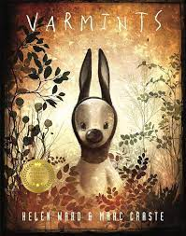 | The Adventures of Odysseus Hugh Lupton & Daniel Morden, Christina Balit  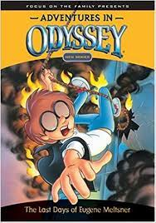 | Poems the Wind Blew In Karmelo C Iribarren, Riya Chowdhury  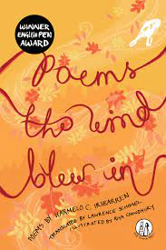 | Mama Miti: Wangari Maathai & the Trees of Kenya  Donna Jo Napoli, Kadir Nelson  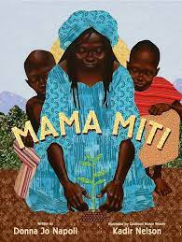 | Runaway Robot  Frank Cottrell Boyce, Steven Lenton  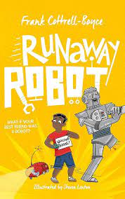
Written Outcomes:  Memoir (illustrated) Documentary script Emails & postcards |  | Written Outcomes:  Persuasive poster Newspaper article Writing in role | Written Outcomes:  Newspaper article Speech writing  Narrative in graphic form | Written Outcomes:  Poetry in a range of forms | Written Outcomes:  Science Investigation Summative Report Instruction Manual  Persuasive speech | Written Outcomes:  Writing in role: journal and letter Alternative viewpoint retelling Referential writing based on research
Purpose: Inform |  | Purpose: Persuade, inform | Purpose: Inform, entertain | Purpose: Entertain | Purpose: Inform, persuade | Purpose: Inform, entertain
Grammar overview:  Tense choices  Adverbs or modal verbs for degrees of possibility  Synonyms & antonyms  Verb prefixes (e.g., dis-, de-, mis-, re-) Figurative language, including metaphor, simile, personification  Adverbials of time, place & number Commas to clarify or avoid ambiguity Compare standard English forms and spoken forms  Direct Speech punctuation  Range of layout devices (e.g., headings, columns, tables) |  | Grammar overview:  Progressive form of verbs to mark actions in progress  Formation of verbs using suffixes (-ate, - ise, -ify)  Figurative language, including metaphor, simile, personification  Synonyms & antonyms Passive and active voice Independent clauses (semi- colon/colon/dash)  Adverbs or modal verbs for degrees of possibility  Wider range of cohesive devices (repetition, adverbials, ellipsis) | Grammar overview:  Traditional tale voice  Commas to clarify or avoid ambiguity Progressive form of verbs to mark actions in progress  Formation of verbs using suffixes (-ate, - ise, -ify)  Brackets, dashes or commas to indicate parenthesis  Explore levels of formality Adverbials of time, place & number  Fronted adverbials & conjunctions in co- ordinating & relative clauses  Devices to build cohesion within a paragraph | Grammar overview:  Verb prefixes (e.g., dis-, de-, mis-, re-) Looking at language  Progressive form of verbs to mark actions in progress  Brackets, dashes or commas to indicate parenthesis  Tense choices  Figurative language, including metaphor, simile, personification  Passive and active voice  Punctuation for effect, clarity & cohesion Synonyms & antonyms | Grammar overview:  Non-fiction explanatory voice Identifying bias  Passive and active voice  Adverbs or modal verbs for degrees of possibility  Range of layout devices (e.g., headings, columns, tables)  Paragraphs to organise ideas Present perfect tense consistency  Formation of verbs using suffixes (-ate, - ise, -ify)  Semi-colon, colon and dash to mark clauses and/or in lists  Explore levels of formality | Grammar overview:  Narrative voice  Use of present tense and/or past tense Progressive form of verbs to mark actions in progress  Devices to build cohesion within a paragraph  Conjunctions and fronted adverbials Adverbs or modal verbs for degrees of possibility  Compare standard English forms and spoken forms  Direct Speech punctuation Explore levels of formality
Key Vocabulary:
To recognise and use the terms;
Year 6: subject, object, active, passive, synonym, antonym, ellipsis, hyphen,
colon, semi-colon and bullet points.
Year 5: modal verb, relative pronoun, relative clause, parenthesis, bracket, dash, cohesion and ambiguity.
Handwriting:
Pupils should be taught to:
-choosing which shape of a letter to use when given choices and deciding whether or not to join specific letters;
- choosing the writing implement that is best suited for a task.

