Class 1 weekly update

(12th- 16th September 2022)

Our learning theme this week is: Our feelings
Books of the week: Colour Monster by Anna Llenas Poem of the week: Happy to be me
PE- We are going to be learning to jump in different ways, making sure we land safely.
Collective worship: Our Bible story this week is the Parable of the Mustard Seed. We will also be learning some new songs with actions about how special we are.
We are going to be talking to the children about the Zones of Regulation this week and helping the children to identify and label their feelings. Take a look at the Early Years section of the website to find out more.

Nursery

- We are going to be listening to the story of the Colour Monster this week and retelling it with our story spoons
- We will be practicing our super counting from 0-5 and perhaps beyond!
- We are going on a colour scavenger hunt! How many blue things can you spot at home?

Reception

- We are excited that we are going to be starting our Phonics journey this week! The new sounds that we are learning are: s, a, t, p. We will begin putting these sounds together to attempt reading simple words! Can you spot any of these sounds in your home?
- In our Maths carpet time this week, we will be working on recognising numbers to 10 and putting them in the correct order.
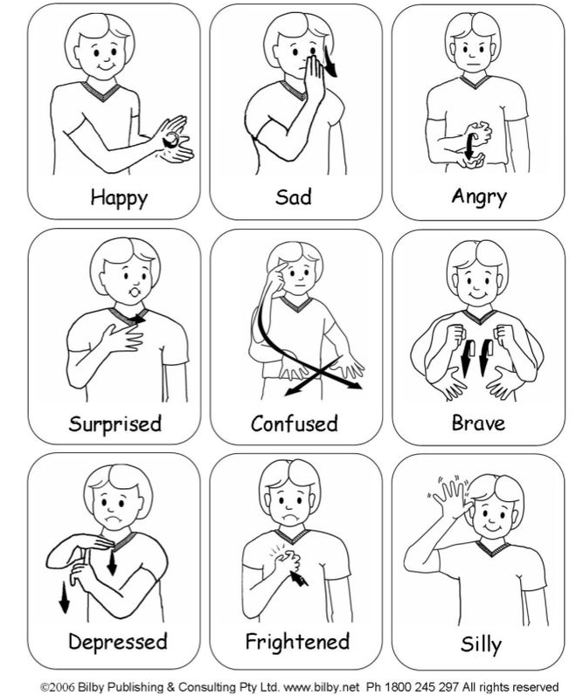
We are going to be looking at the work of artist Guiseppe Arcimboldo this half term. The children are going to use food to create their own pieces of art this week, inspired by his work. Look out for these coming home!
A few reminders
Start time
Just to remind you that our doors will open at 8:35am and the register is taken at 8:45am. Any arrival after this time will unfortunately be marked as late.
Family photos
Thank you to everyone who has bought in photos already. This is a gentle reminder to bring family photos in this week (or email/upload to Evidence me). They will be shared by the children during our topic on families.

Makaton signs of the week

