Class 1 weekly update

(3rd- 7th October 2022)

Our learning theme this week is: Our Homes/ Harvest
Books of the week: Goldilocks and the Three Bears Poem of the week: Pumpkin Patch
Collective worship: In God’s Garden Leaving God’s Garden Genesis 2- 3
You may wish to try our collective worship song this week: God Made Me https://www.youtube.com/watch?v=4iW9MN7vMpQ
Nursery

- We are going to be listening carefully to the story of Goldilocks and the Three Bears and using our story spoons and puppets to retell the story.
- Our gross motor focus this week is ball skills. We will be going onto the big playground to practise. One of our fine motor skills activities will be ‘crazy hair threading!’ Look out for some photos on Evidence Me!
Reception

- In phonics we will be learning the sounds: ck, e, u, r. We will also be learning to recognise the tricky words ‘to and the’.
- Look out for some letter flashcards coming home this week along with tips shared on Evidence me on how to use the cards for recognition and blending.
- In maths this week our focus is on accuracy when counting objects. Can you count your teddies/soft toys accurately?
Porridge!
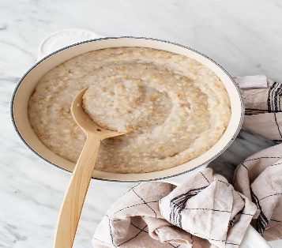
As our story is Goldilocks and the Three Bears we will be making (and eating) porridge on Tuesday to see if we can get it ‘just right!’ The children will be designing their perfect recipe and cutting fruit from our snack basket to top it with.
Any questions or concerns please do speak to one of the team.

Makaton sign of the week
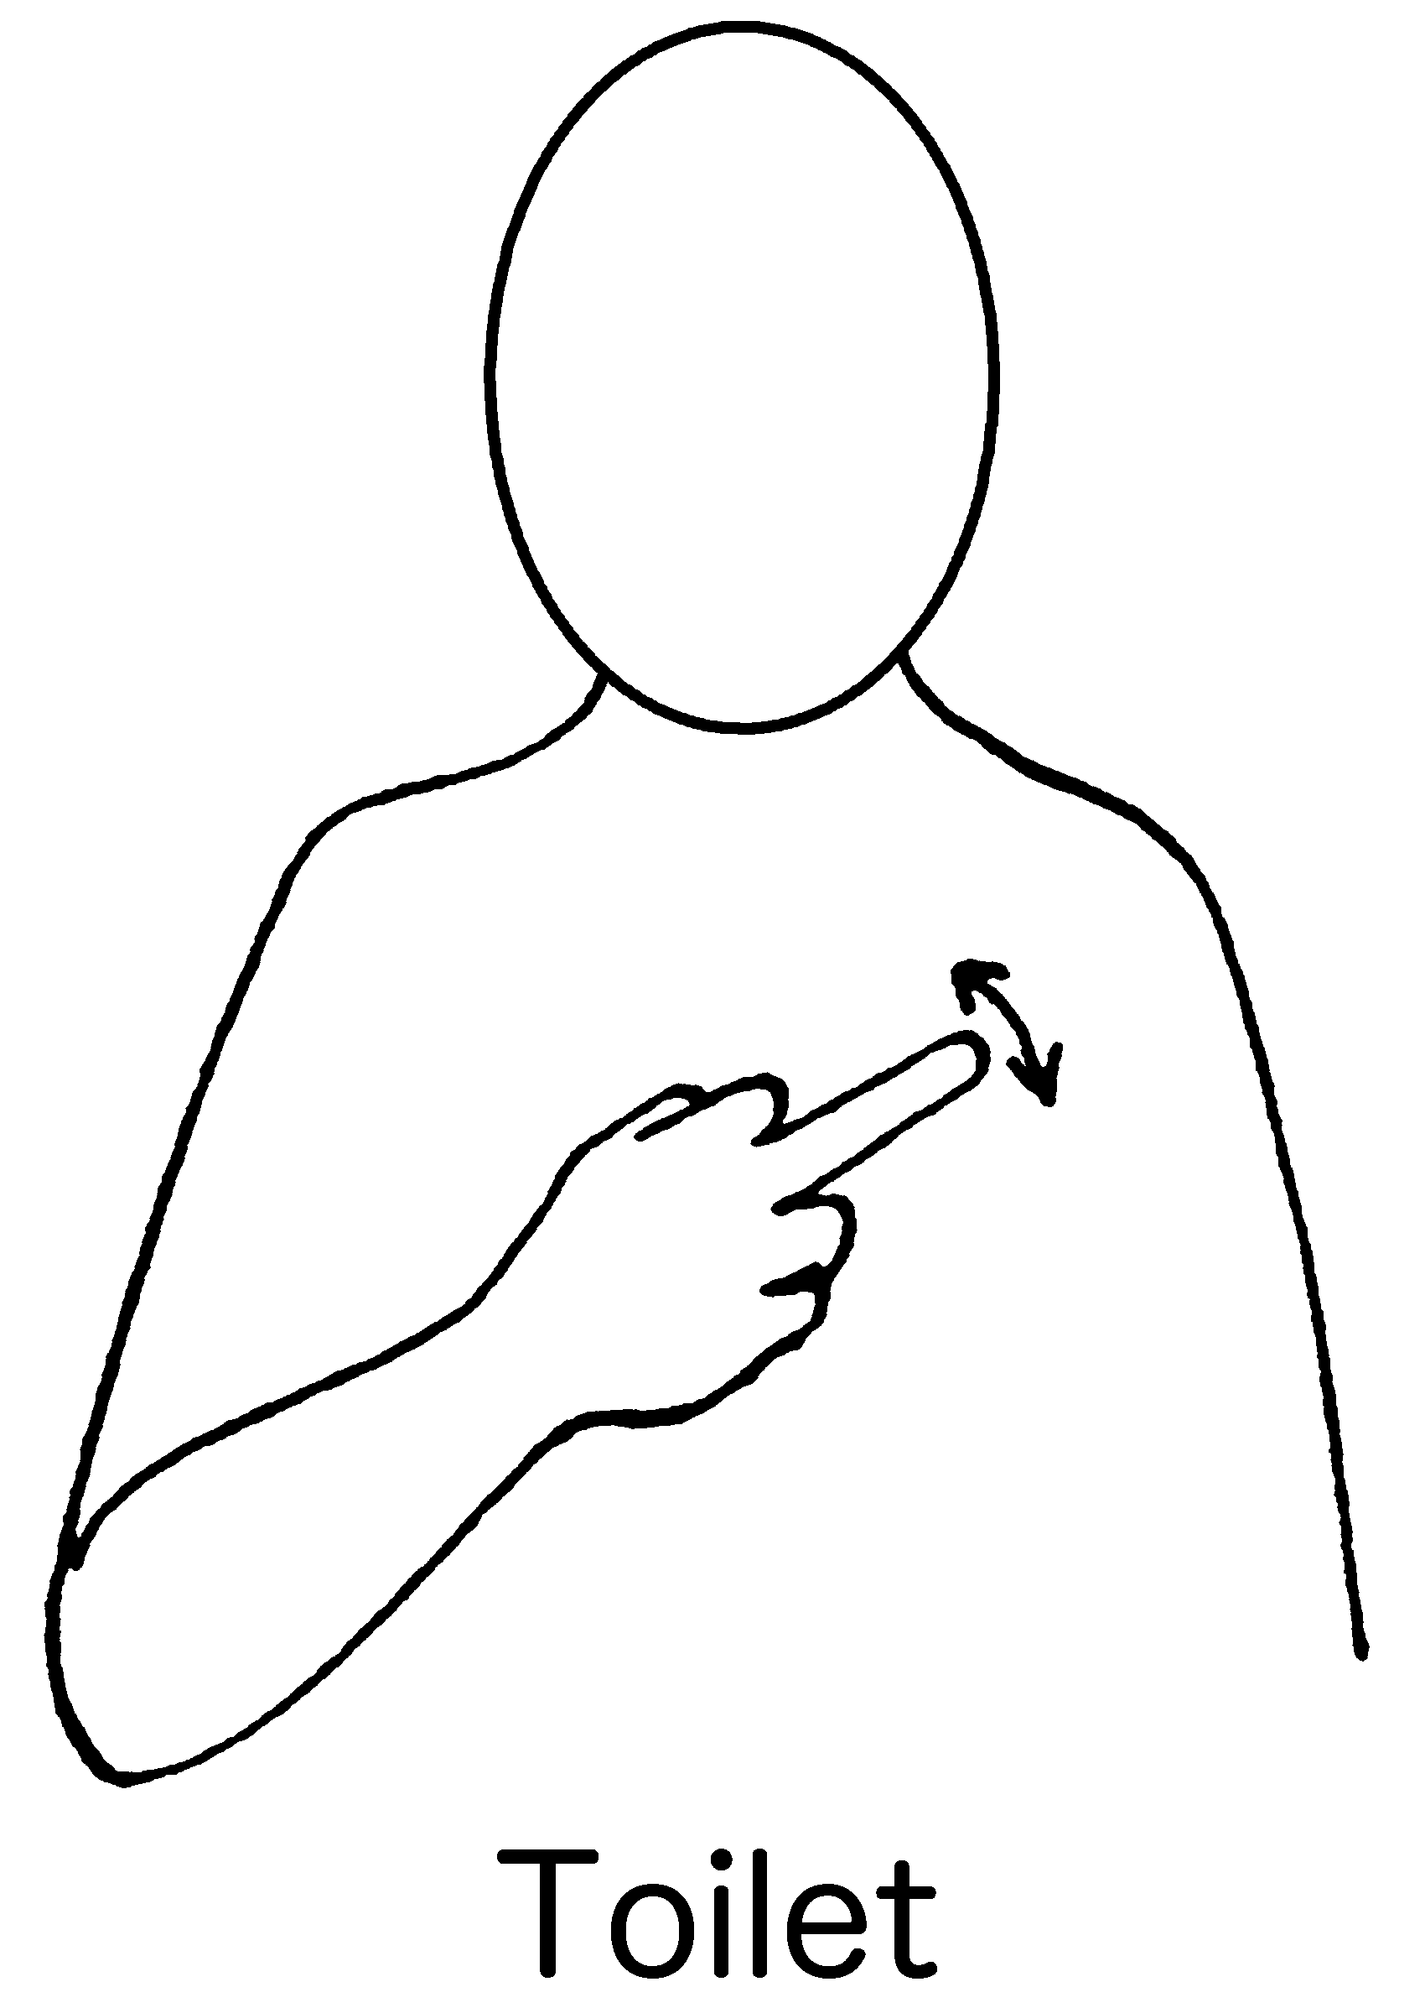
Autumn Treasures:
Please remember to return your bag of autumn treasures for the children to share and explore together. The changing seasons are an important part of the curriculum, learning about the world around us and the natural changes that take place.

School Website
Please take a look at the ‘Early Years Foundation Stage’ section of our Cadmore End School website. 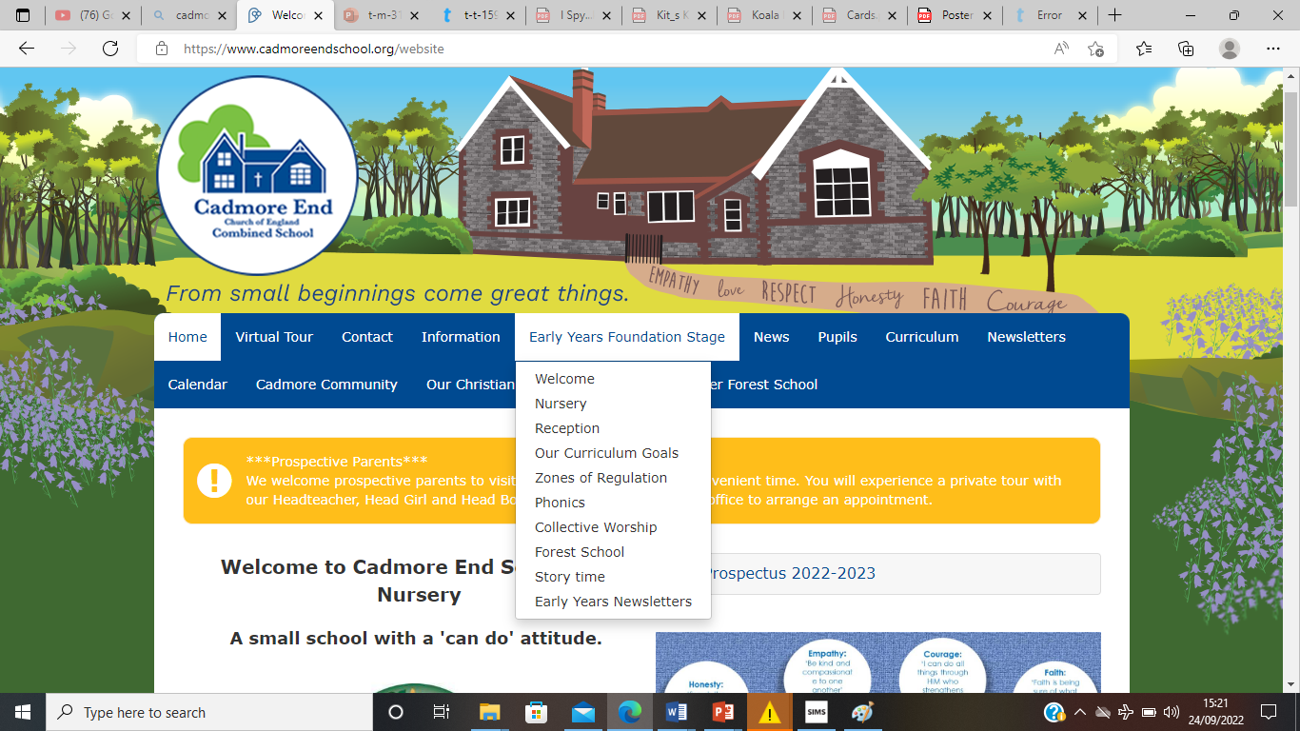
We have also updated our section of the website with lots of information about our curriculum, videos of our collective worship songs and much more. You can even have a look around our classrooms or watch a bedtime story from the teachers! Why not take a look?

