Wellbeing Newsletter
February 2026
We hope you all enjoyed quality time over the festive period with your families and friends, and that your children are feeling rested and ready for the academic year ahead.
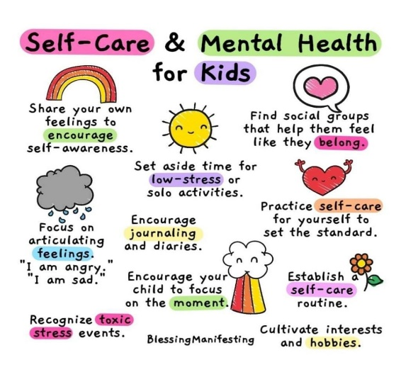
At Cadmore End School, we are committed to supporting the wellbeing and mental health of our children, staff and families. We recognise that wellbeing – both physical and mental – is vital for successful learning. Our aim is to share helpful tips, guidance and resources to support both adults and children, as we understand how important it is for parents and carers to feel supported and well themselves.
Parents Toolkit
BBC Bitesize offers a range of wellbeing tips designed to support parents in nurturing a healthy, happy childhood, including advice on anxiety, after-school ‘meltdowns’, and ways to look after both your own mental health and your child’s.
https://www.bbc.co.uk/bitesize/groups/cw9v6l8d0q6t

If you need support…
Family Information Service (help with finances, wellbeing, housing)
Restore Hope – 01494 765555
MIND – 01296 43732
Chiltern Foodbanks – 0808 2082138
Employment Support – 01494 463364 EXT 2
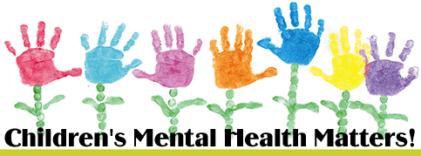
Safe Haven Crisis support – 01494 218098

