Half Term Forest School Challenges

**Signs of spring**

<https://5c572be4-4697-4e25-b4e0-76a29e5bcb61.filesusr.com/ugd/b2aed2_0e76825d4cb149a6ae568250fbc48eaa.pdf>

**How to estimate the age of a tree**

<https://5c572be4-4697-4e25-b4e0-76a29e5bcb61.filesusr.com/ugd/b2aed2_8d3a93d976454b1f8760e148a03dee8c.pdf>

**Natural Noughts & Crosses**

<https://5c572be4-4697-4e25-b4e0-76a29e5bcb61.filesusr.com/ugd/b2aed2_e77ce8078741401f9bb2572ec1285881.pdf>

**Woodland Word search**

[**https://www.stem.org.uk/system/files/community-resources/2016/02/Tree%20Name%20Wordsearch.pdf**](https://www.stem.org.uk/system/files/community-resources/2016/02/Tree%20Name%20Wordsearch.pdf)

**Forest school Activities**

[**https://www.youtube.com/channel/UCJ5_Cx2JrbGdtSyH**](https://www.youtube.com/channel/UCJ5_Cx2JrbGdtSyH)

**Animal Track Activity**

[**https://www.ltl.org.uk/resources/animal-track-trap/**](https://www.ltl.org.uk/resources/animal-track-trap/)

**Forest Bathing**

[**https://www.ltl.org.uk/resources/forest-bathing/**](https://www.ltl.org.uk/resources/forest-bathing/)

**Simple peeler whittling**



[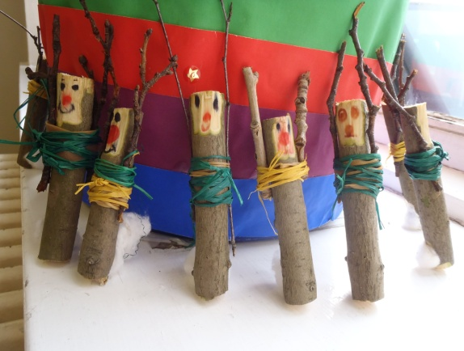](https://www.google.co.uk/url?sa=i&url=https%3A%2F%2Fwww.pinterest.at%2Fpin%2F420734790181913436%2F&psig=AOvVaw0gNt2c7qEhzVMwzY_UVQM_&ust=1613143419647000&source=images&cd=vfe&ved=0CAIQjRxqFwoTCNj6j-eR4u4CFQAAAAAdAAAAABAJ)[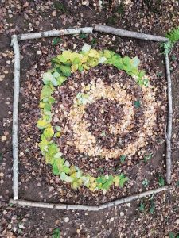](https://www.google.co.uk/url?sa=i&url=https%3A%2F%2Fwww.creativeoutdoorlearning.co.uk%2F&psig=AOvVaw0gNt2c7qEhzVMwzY_UVQM_&ust=1613143419647000&source=images&cd=vfe&ved=0CAIQjRxqFwoTCNj6j-eR4u4CFQAAAAAdAAAAABAD)

Nature Art

[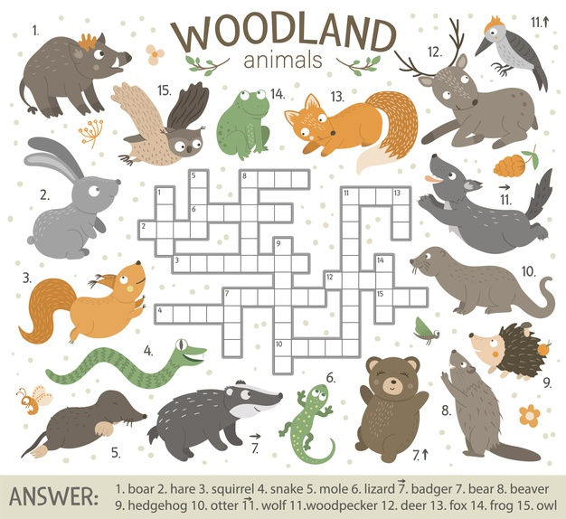](https://www.google.co.uk/url?sa=i&url=https%3A%2F%2Fwww.freepik.com%2Fpremium-vector%2Fcrossword-puzzle-with-forest-animals_10244472.htm&psig=AOvVaw1MXdMyIAr8aVAH96zpCQ9y&ust=1613139708245000&source=images&cd=vfe&ved=0CAIQjRxqFwoTCOjxjPKD4u4CFQAAAAAdAAAAABAD)

[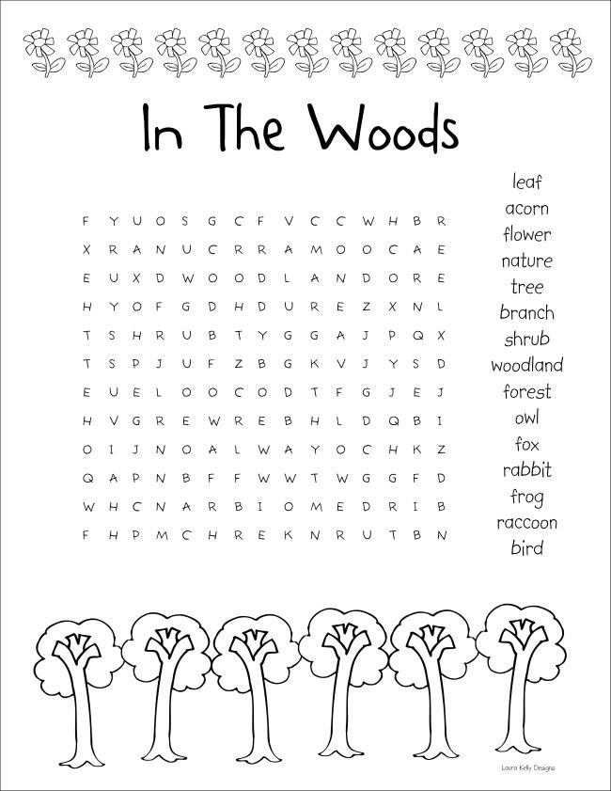](https://www.google.co.uk/url?sa=i&url=https%3A%2F%2Fwww.pinterest.com%2Fpin%2F87468417741632516%2F&psig=AOvVaw3U-iFIrZdLoME_PbACMaci&ust=1613139127746000&source=images&cd=vfe&ved=0CAIQjRxqFwoTCMjCm9mB4u4CFQAAAAAdAAAAABAJ)