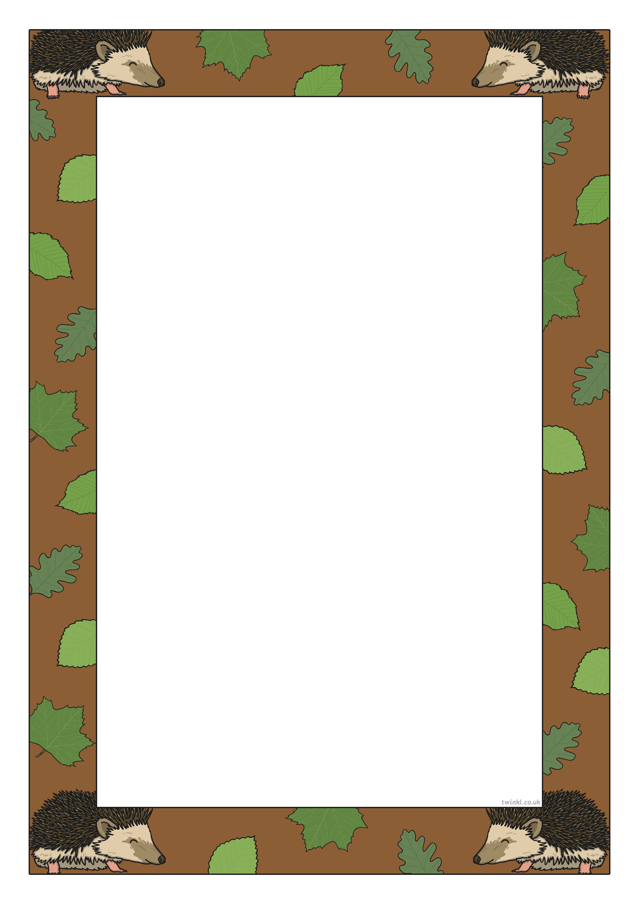
Class 1 weekly update
27th November 2023
Our learning theme this week is: Hibernation
Book of the week: Percy the Park Keeper
Worship song of the week: God is Greater
Nursery
- We will be learning how to sign ‘Hibernate’ and ‘Winter’ in Makaton
- In talk time we will be learning about what hibernation means and which animals hibernate
- We will continue our work on 2D shapes by making shape pictures
Can you name these shapes?

Reception
- In Phonics this week we will be learning some new sounds, y, z, zz, as well as our first set of digraphs (when 2 letters make 1 sound): qu, ch,
- Can you segment these words by putting the sounds on your fingers?
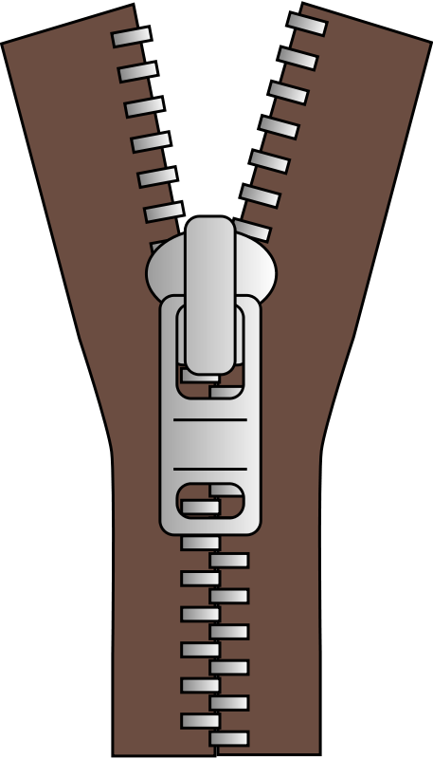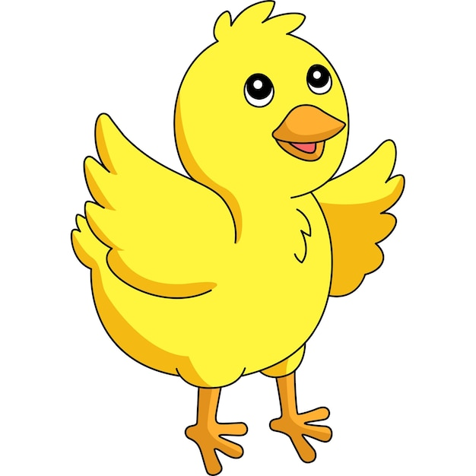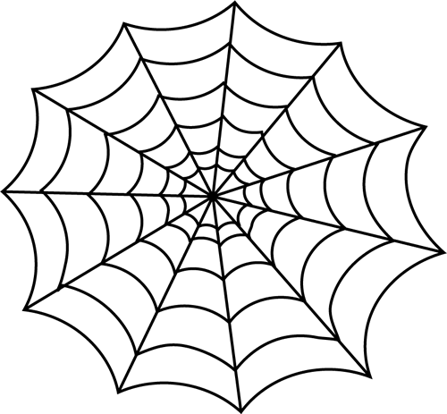
- In Maths we will be looking at the composition of number, including how we can make 5 (4 and 1; 2 and 3 etc)
- We will be practising our writing and having a go at labelling a hibernating animal!

