Class 1 weekly update
(6th November – 10th November 2023)

Our learning theme this week is: Diwali/Remembrance Day
Book of the week: The Runaway Chapatti
Collective worship: We will share ‘A new life for Abraham’ together
Makaton Signs of the week: Poppy
Nursery
- We will be creating Rangoli patterns using loose parts for Diwali.
- In Maths we will be comparing size and weight.
- In literacy we will be learning the poem/rhyme ‘Little lamps’ and listening carefully in Phonics to play Forest sound bingo.
Cut the poppies out and order them from the biggest to the smallest!
Reception
- In Phonics this week we will be focusing on blending and segmenting sounds we have learnt so far.
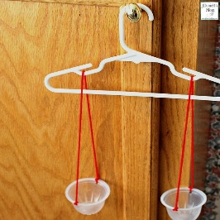
- In Maths we will be comparing objects by weight this week and focusing on the vocabulary ‘heavy ‘and ‘light’.
Make your own set of weighing scales at home and explore the weights of different objects!
- We will be cooking Chapattis to help us learn about Diwali and as an introduction to our book of the week. As well as exploring different types of poppy art to mark Remembrance Day.

