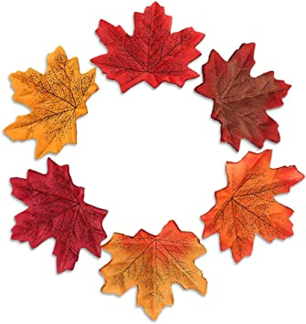
Class 1 weekly update

(13th-19th November 2023)

Our learning theme this week is: Nursery Rhymes
Collective worship: We will be learning the song ‘My Lighthouse’

Nursery
- The children will be listening to and learning lots of nursery rhymes and do a tally to see which is the most popular.
Which is your favourite nursery rhyme that you sing at home? Can you sing it to your grown up?
- In talk time, the children will be thinking about how heavy and light different objects are. Their challenge is to compare them and decide which things weigh more or less!

Reception
- In phonics the children will recapping the sounds i,p,n,m as well as our tricky words, the, to, I no, go. We will also be practising our blending skills.
Which of these is a p-i-g? Which is the s-u-n? Which is a c-u-p?

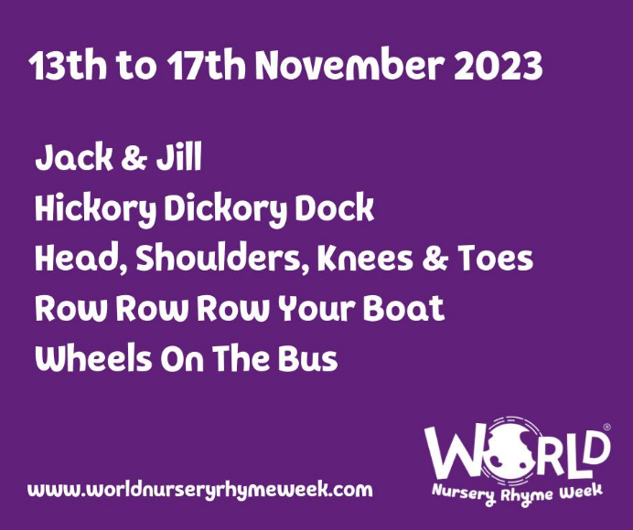
- In Maths we will be comparing two sets of objects to see which has more and less. We will also be learning about capacity and using dried pasta to make containers full, empty and half full.
Nursery Rhyme Week
There are lots of amazing benefits to children learning nursery rhymes. They are great for language acquisition and they help with speech development. They also help children develop auditory skills such as discriminating between sounds.
Class 1 are joining in with the Nursery Rhyme challenge this week by learning one rhyme each day. You can take a look at the website and listen to the songs at home!

