Your Text Here

Class 1 weekly update
20th – 25th November 2023

Our learning theme this week is: Road Safety
Book of the week: Super Cat’s Road Safety
Nursery
- We will be looking at the pattern of traffic lights and making prints to help us understand about our topic road safety.
- In Maths we will be constructing with shapes to make transport pictures.
- In literacy we will be learning the poem/rhyme ‘Stop, Look & Listen’ to help us stay safe around roads and listening carefully in Phonics to Red Riding Hoods basket.
Play a game to reinforce left and right e.g. jump to right, clap to the left…!
Reception
- In Phonics this week we will be moving onto level 3 and learning the sounds j, v, w, x.
- In Maths we will be identifying and continuing repeating patterns.
Can you draw and colour the next two cars in the pattern?
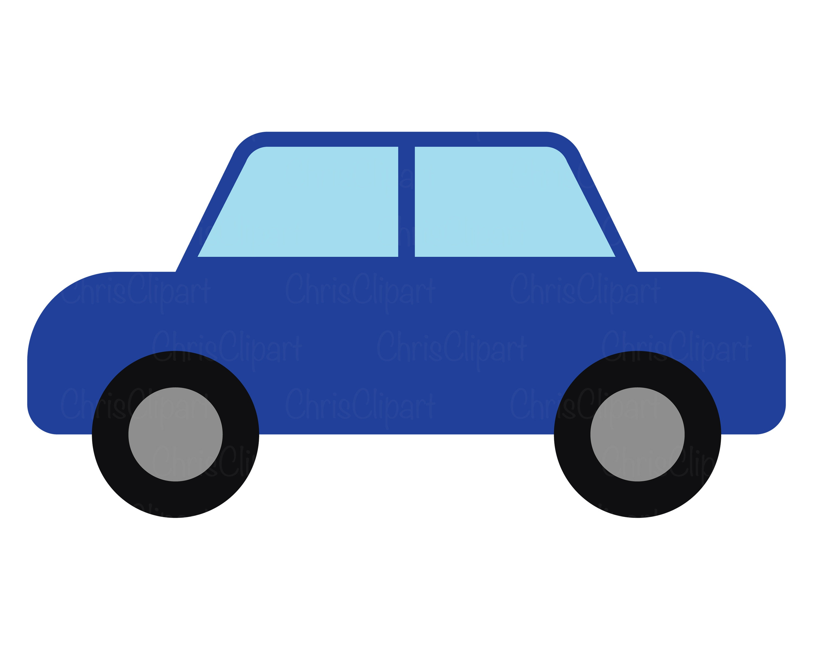
- We will be exploring different materials with torches to learn how these can help us to stay safe around roads during the winter months and at night time.

Gentle reminder:
Please ensure long hair is tied back and any hair falling over the children’s eyes is secured away from their faces. This will help with clear vision for learning and to avoid any possible transmission of head lice. Thank you.

