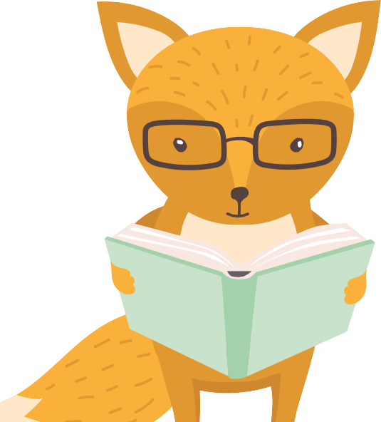

Chatting, playing and reading are all fun ways to bond with children and help them to get better at learning. It’s never too early to help
develop children’s communication, speech, reading and writing skills.
Top Tips for chatting
with young children

Ensure the child is given the opportunity to take part in general conversation with an adult every day.
Ask open-ended questions. These can’t be answered with a yes or no answer and tend to start with a ‘what’, ‘how’, ‘where’ or ‘why’. For example, “What are you drawing?”
Encourage make-believe and pretend play. When a child is playing their imagination will take over leading to great opportunities for talking.

Listen more than you talk. This is a fantastic opportunity to teach children good speaking and listening skills.
When chatting with a child, crouch or sit down so that you are at the same level, giving eye contact and using facial expressions and gestures will show you are listening.
Give children plenty of time to respond, sometimes children need a little while to process the information before they reply.

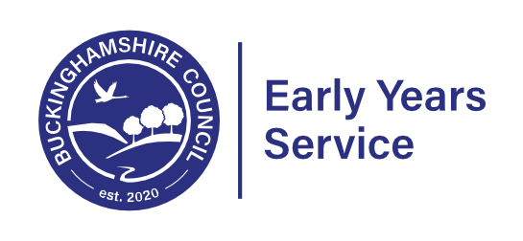
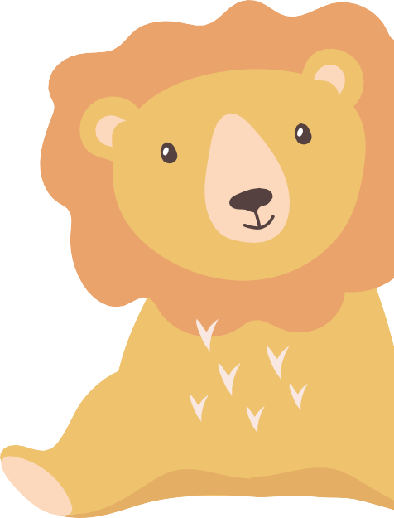
It may seem an obvious thing to say, but one of the best things we can do with young children is to have interesting and enjoyable
conversations with them
Michael Rosen, Children’s Laureate
By 5 years of age a child’s vocabulary can predict his/ her educational success and
outcomes at age 30
ICAN: ELDP (2012)
Our babies love to hear our voices. As early as when they are in the womb, they start to tune into the voices and sounds around them,
and often respond to more familiar voices.
National Literacy Trust

Language development is strongly supported by
being active
(Jan White: Every Child
A Mover 2015)

Reading and writing float on a sea of talk
James Britton, Educationalist
Find out more about your Child’s development
What to Expect When in the Early Years Foundation Stage, a Guide for Parents
If you have any concerns about your child’s development the first thing to do is talk to your child’s key person at their childminder / nursery / pre-school.
Find out more
- Words for Life - ideas for Parents
- Start for Life - Learning to talk
- BBC Tiny Happy People
- Buckinghamshire Family Information Service

