Class 1 weekly update

(26th- 30th September 2022)

Our learning theme this week is: Our Homes/ Harvest
Books of the week: Billy Goats Gruff Poem of the week: Happy House
Collective worship: We will be thinking about what we are grateful for and we will be thanking God for the Harvest of fruit and vegetables from our wonderful world
Nursery

- We are going to be listening carefully to the story Billy Goats Gruff and using our story spoons to retell the story.
- We are also going to learning all about 2D shapes! Can you spot a circle, triangle or square in your house?
Reception

- In phonics we will be learning the sounds: g, o, c, k. We will also be learning to recognise tricky word ‘and’. Why don’t you have a look on Evidence me to find a phonics recap video from last week? How many sounds can you remember? Can you write any of them?
- In our Maths carpet time this week we will be learning all about patterns. We are going to be making a repeating pattern fruit kebab and doing lots of activities to help us practice. Can you finish this pattern?
Evidence Me
Hopefully you will have started to see photos and videos of your child on your Evidence Me account. We would love to invite parents to also share pictures or videos of anything that your child does at the weekend or any special clubs that they are part of. The children love sharing these with their friends during our carpet times!
If you’re having any technical issues or would like to know more about how to use it, please ask one of the members of staff. We are happy to help

School Website
Thank you to the parents who attended out phonics workshop last week. If you couldn’t make it, or would like to find out more about phonics, please take a look at the ‘Early Years Foundation Stage’ section of our Cadmore End School website. 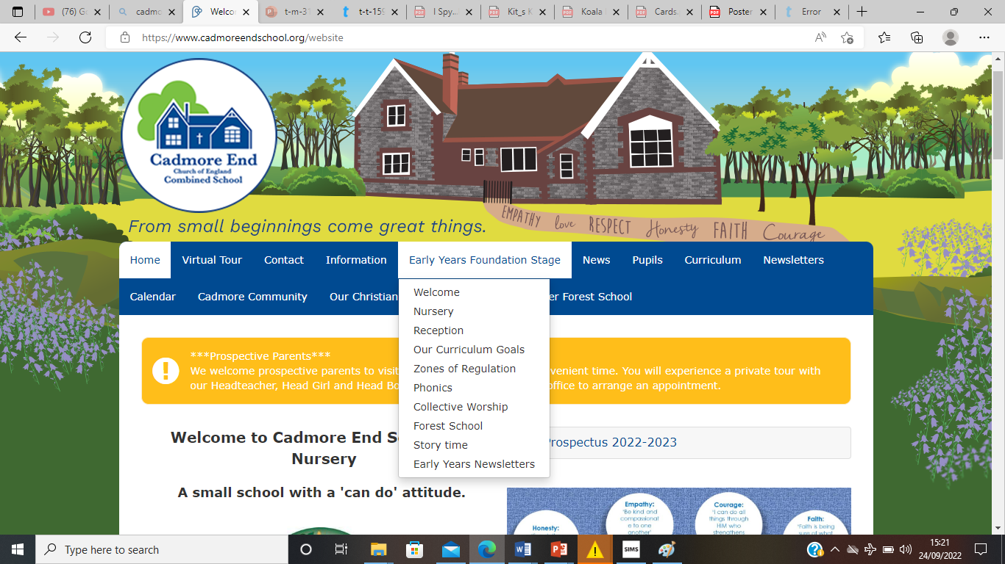
We have also updated our section of the website with lots of information about our curriculum, videos of our collective worship songs and much more. You can even have a look around our classrooms or watch a bedtime story from the teachers! Why not take a look?

Harvest Assembly
Just a reminder that we will not be taking part in the Harvest service at the Church on Friday with the rest of the school. Instead, the children will be performing a song or two of their own at 9am in the hall. We hope to see you there. If you cannot make it, don’t worry. We will record the performance and share it on Evidence me so keep your eyes peeled!

