Class 1 weekly update

(21st-25th ^{th} November 2022)

Our learning theme this week is: Road Safety
Collective worship: Rules from God Exodus 19:16 – 20:17 Worship Song: God is Greater

Nursery
- This week nursery will be looking at numbers 1 and 2, singing, counting and writing.
- In phonics we will be listening to animal sounds and matching to the correct pictures to improve our listening skills.
- Along with Reception, we will also be focusing on Road safety with stories and a look at the Green Cross Code. Talk to your child about keeping safe when crossing the road with you.

Reception
- In phonics the children will be revisiting the digraphs qu, ch from last week and will also be learning sh, th (unvoiced- meaning, only air passes through the mouth, without using the vocal cords. This sound is common in most words that begin with “th.” “Think,” “third,” and “thank” all start with the voiceless “th.” We will be learning the tricky words ‘we, me, be ‘. Look out for new tricky words in your child’s book bag later this week once they have been taught in school.
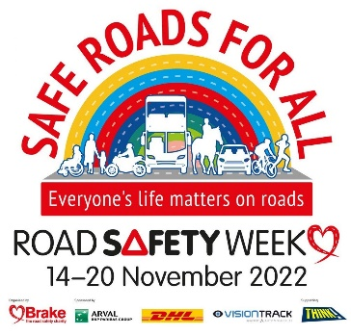
- In Maths we will be continuing to practice our number formation up to number 5. Look out for a number formation sheet this week to support your child! We will also be sorting vehicles by the number of wheels. And counting along a number line.
Beep, Beep Day!
Don’t forget we will be hosting our own ‘Beep. Beep day’ on Thursday 24th!

Please remember your child’s bike or scooter along with a helmet if you have one.

Road Safety Week
The theme of Road Safety Week 2022 is SAFE ROADS FOR ALL. Do check out: https://www.brake.org.uk/road-safety-week for more information.
The children will be thinking about people who help us, such as lollypop men and ladies and the emergency services.
The children will be learning through stories and role play how to keep safe when crossing a road.
We will be thinking about who uses the roads and the types of signs they need to be aware of. We will also be completing a simple traffic survey looking at the road users by our school.

