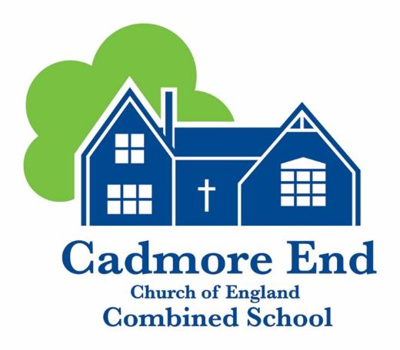

Early Years Foundation Stage
(EYFS) policy

Created September 2021
Reviewed and updated September 2023
Reviewed June 25
Next Review September 2026

Contents

1. Aims 3
2. Legislation 3
3. Structure of the EYFS 3
4. Curriculum 3
5. Assessment 4
6. Working with parents 5
7. Safeguarding and welfare procedures 5
8. Monitoring arrangements 5
Appendix 1. List of statutory policies and procedures for the EYFS 6



EYFS Policy
2025-2026
‘From small beginnings come great things’ The Parable of the Mustard Seed
Matthew 13: 31-32

At Cadmore End we will strive to apply our Christian and British values, complemented by our small-school benefits; balancing each child's educational, pastoral and emotional needs to deliver an exceptional, personalised experience, enabling them to flourish in our family and in the future.

1. Aims
This policy aims to ensure:
- That children access a broad and balanced curriculum that gives them the broad range of knowledge and skills needed for good progress through school and life
- Quality and consistency in teaching and learning so that every child makes good progress and no child gets left behind
- A close working partnership between staff and parents and/or carers
- Every child is included and supported through equality of opportunity and anti-discriminatory practice

2. Legislation
This policy is based on requirements set out in the statutory framework for the Early Years Foundation Stage (EYFS) that applies from September 2021.

3. Structure of the EYFS
Our Early Years provision is for 3-5 year olds. Children can enrol at our Nursery from the term following their third birthday. We offer nursery children 15 hours and 30 hours to those families that are eligible. Please see our admissions policy for further information.

4. Curriculum
Our early years setting follows the curriculum as outlined in the latest version of the EYFS statutory framework that applies from September 2021.
The EYFS framework includes 7 areas of learning and development that are equally important and inter-connected. However, 3 areas known as the prime areas are seen as particularly important for igniting curiosity and enthusiasm for learning, and for building children’s capacity to learn, form relationships and thrive.
The prime areas are:
- Communication and language
- Physical development
- Personal, social and emotional development
The prime areas are strengthened and applied through 4 specific areas:
- Literacy
- Mathematics
- Understanding the world
- Expressive arts and design
4.1 Planning
A carefully devised two year long term plan, aims to match and enhance the cultural capital of our cohort. Our learning environment is led by the school vision and our rural setting that is utilised throughout our planning with regular use of our forest school.
Staff plan activities and experiences for children that enable children to develop and learn effectively. In order to do this, staff working with the youngest children are expected to focus strongly on the 3 prime areas.
Staff also take into account the individual needs, interests, and stage of development of each child in their care, and use this information to plan a challenging and enjoyable experience. Where a child may have a special educational need or disability, staff will work in partnership with parents and the SENDCO, linking with relevant services from other agencies, where appropriate to ensure the best support is given.
In planning and guiding children’s activities, staff reflect on the different ways that children learn and include these in their practice.
4.2 Teaching
Each area of learning and development is implemented through planned, purposeful play, and through a mix of adult-led and child-initiated activities. Staff respond to each child’s emerging needs and interests, guiding their development through warm, positive interaction. Our school’s mission, “from small beginnings come great things” is threaded throughout our positive relationships with the children. We offer a personalised curriculum to strive towards meeting each child’s needs and closing the gaps, where necessary.
As children grow older, and as their development allows, the balance gradually shifts towards more adult-led activities to help children prepare for more formal learning, ready for year 1.

5. Assessment
At Cadmore End School, ongoing assessment is an integral part of the learning and development processes. Staff observe pupils to identify their level of achievement, interests and learning styles. These observations are used to shape future planning. Staff also take into account observations shared by parents and/or carers through the online platform ‘Evidence Me.’
Within the first 6 weeks that a child starts reception, staff will administer the Reception Baseline Assessment (RBA) alongside their own assessment for all Early Years children.
At the end of the EYFS, staff complete the EYFS profile for each child. Pupils are assessed against the 17 early learning goals, indicating whether they are:
- Meeting expected levels of development
- Not yet reaching expected levels (‘emerging’)
The profile reflects ongoing observations, and discussions with parents and/or carers. The results of the profile are shared with parents and/or carers for their child.
The profile is moderated internally (referring to the Development Matters guidance) and in partnership with other local schools, to ensure consistent assessment judgements. EYFS profile data is submitted to the local authority.

6. Working with parents
We recognise that children learn and develop well when there is a strong partnership between staff and parents and/or carers. We believe in an ‘open door policy’ with informal discussions taking place on a daily basis at drop off and collection times.
Parents and/or carers are kept up to date with their child’s progress and development at regular parent and teacher consultations. The progress check and EYFS profile helps to provide parents and/or carers with a well-rounded picture of their child’s knowledge, understanding and abilities. We share observations and achievements with parents and carers through the online platform ‘Evidence Me’ and encourage them to do the same.
The school offers parent/carer workshops around early phonics and mathematics. Parents are given weekly updates on what their child has been learning about at school this week and suggestions are made about activities which can be done at home. Reception children also have a reading book and reading record, where parents are encouraged to read with their child on a daily basis.
Each child is assigned a key person who helps to ensure that their learning and care is tailored to meet their needs. The key person supports parents and/or carers in guiding their child’s development at home. The key person also helps families to engage with more specialist support, if appropriate.

7. Safeguarding and welfare procedures
We recognise that children learn best when they are healthy safe and secure, when their individual needs are met and when they have positive relationships with the adults caring for them. We follow safeguarding and welfare requirements to provide a welcoming, safe and stimulating environment where children are able to enjoy learning and grow in confidence.
We make sure that the appropriate statutory staff child ratios are maintained in our setting to meet the needs of all children and ensure their safety. We take children the term after they turn 3 years. We determine ratios guided by all relevant ratio requirements and by the needs of the children within the group
Staff in Early Years are paediatric first-aid trained and this is refreshed every 3 years.
We promote good oral health, as well as good health in general, in the early years by talking to children about:
- The effects of eating too many sweet things
- The importance of brushing your teeth
- Taking part in regular physical activity
- Importance of healthy eating
- Sensible amounts of screen time
- Having a good sleep routine
- Being a safe pedestrian
We follow statutory guidance for safety around supervised tooth brushing.
The rest of our safeguarding and welfare procedures are outlined in our safeguarding policy.

8. Monitoring arrangements
This policy will be reviewed and approved by the headteacher and EYFS Governor every couple of years.
At every review, the policy will be shared with the governing board.

Appendix 1. List of statutory policies and procedures for the EYFS

Statutory policy or procedure for the EYFS | Where can it be found?
Safeguarding policy and procedures | See child protection and safeguarding policy
Procedure for responding to illness | See health and safety policy
Administering medicines policy | See supporting pupils with medical conditions policy
Emergency evacuation procedure | See health and safety policy
Procedure for checking the identity of visitors | See child protection and safeguarding policy
Procedures for a parent failing to collect a child and for missing children | See child protection and safeguarding policy
Procedure for dealing with concerns and complaints | See complaints policy
All are found on our school website www.cadmoreendschool.org

