Class 1 weekly update
15th – 19th January 2024
Our learning theme this week is: Space rockets
Book of the week: ‘Whatever Next’ by Jill Murphy
The children are really enjoying our space topic and this week will be watching videos of rocket launches and learning key vocabulary based on space and rockets.
Nursery
- In Maths we will be learning about height, using the vocabulary, ‘taller’ and ‘shorter’.
- In literacy we will be learning the poem/rhyme ‘Climb aboard the spaceship’. In Phonics, we will be using instrumental sounds to experiment with how to make noises louder and quieter using different materials.
Can you find 5 things in your house that are shorter than you? Can you find 5 things that are taller than you?
Reception
- The Reception children are now being split into two groups for Phonics. This is to ensure they are working at an appropriate level and any gaps in their knowledge can be filled in. Some of the children will be working with Mrs Sims and continuing to learn new digraphs. The rest of the class will be working with Mrs Deane/Miss Atkins to consolidate the sounds that we have already learnt.
- In Maths we will be learning about shapes with 4 sides and practising sorting these into groups. We will also be practising counting and ordering numbers.

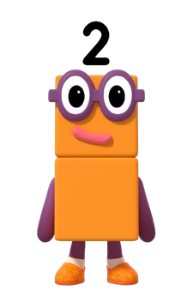
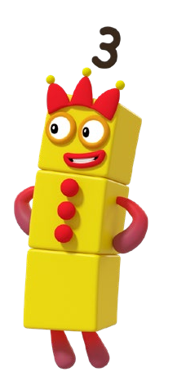
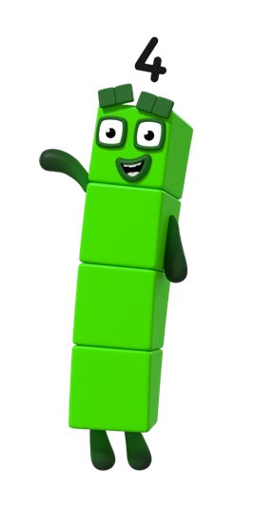
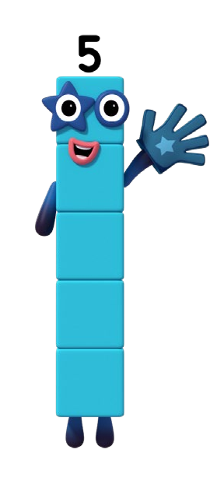
Can you match the numberblocks characters to the correct dice number?
With this extremely cold weather, please remember it is imperative that your child has a warm coat in school every day, as well as gloves and a hat. We would like to encourage the children to be as independent as possible, not only with putting their coat on themselves, but also doing their own zip up. We will be very impressed if children can practise this at home and show us their progress!

